ENDGAME ELEGIES: AN AFFECTIVE DISCOURSE ANALYSIS OF NOSTALGIA AND GRIEF IN IMDB REVIEWS AFTER AVENGERS: ENDGAME

A Thesis
Presented to the Faculty
of Department of English
College of Arts and Sciences
Pampanga State Agricultural University
Magalang, Pampanga

In Partial Fulfillment
of the Requirement for the Degree
BACHELOR OF ARTS IN ENGLISH LANGUAGE STUDIES

By

LINCEY D. BARTOLOME
October 2026

INTRODUCTION

Background of the Study
Online film reviews have become notable sources of public discourse, where users can interact, consult, and share information with each other. In film consumption, users are now able not only to share their evaluation about any film but also access and read evaluations by other users from anywhere in the world (Seixas, 2024). By real-time engagement, film review platforms expanded the parameters of discourse by replacing monologic evaluation with dialogic and collaborative form of film reviews.
According to Onyekwere (2023), film reviewing is the analysis, interpretation, and evaluation of films and their artistic, cultural, and social significance. Traditionally, these reviews are often critical, formulaic and monotonous, centered only on summarizing plotlines and rating. However, in a study done by Mokryn et. al (2020), it was mentioned that viewers' normative emotional responses could also be mined from their online movie reviews rooted in their experience as consumers of media. The study further emphasized that emotions that are evoked by watching can be directed at the (fictional or non-fictional) reality that is being depicted in the film, such as trust in the hero, or fear of the monster, or grief in response to a character’s death. Consequently, these emotionally-driven responses by the reviewer while consuming the film documents not only the subjective opinion on the film, but as well as the specific series of emotions felt during the viewing experience itself.
Digital spaces constitute unique discursive environments where participation is guided by emotional interaction chains. According to Giaxoglou and Döveling (2018), participation in such chains creates subject positions where emotion constitutes a relational resource for alignment and/or misalignment, ultimately producing forms of mediatized emotional resonance. Building on this perspective, emotions and community alignment appear to be influential in shaping how reviewers construct their responses to films. In a study done by Li (2021), she notes that online reviews articulate not only evaluative positions toward the film, but also attitude and feelings of the moviegoers using the Appraisal Framework. Shikalgar and Dixit (2014) also emphasized that reviews that center on appraisal-informed features improve movie review classification and provide a richer picture of how viewers perceive a film emotionally. Studies in discourse such as Onome (2025) where it was analyzed how language in popular music functions as a performative tool for expressing grief and constructing identity, the author emphasized that emotional meaning is rooted through specific linguistic choices particularly evaluative lexical items that encode intensity, stance, and relational positioning. In this sense, expressions of loss in online reviews are shaped by patterned language use that foregrounds affect and aligns individual experience with broader social meanings. These studies therefore suggest that online reviews function as discursive spaces where emotions are not only expressed but also structured, shared, and reinforced within a community.

Nostalgia and Grief
Within this context, emotions such as nostalgia and grief can be traced in the construction of online film reviews. A film contains an amalgamation of diverse features and provides audiences with a variety of reminiscent elements. The content and storylines of films stored in an individuals’ memories can often serve as nostalgic vestiges of times past and can re-encourage an individual to form emotional and symbolic connections with particular stories or scenes (Kim, 2019).
In psychology, nostalgia is defined as an ambivalently felt, affective-cognitive experience. Its cognitive aspects typically consist of a memory of a particular place at a given time (Werman, 1997). Burton (2026) defined it as “a natural, common, and even positive emotion, a vehicle for travelling beyond the suffocating confines of time and space— often prompted by thoughts about the past; particular places and objects; feelings of loneliness, disconnectedness, or meaninglessness” (The Meaning of Nostalgia, para. 7). Extending this understanding to digital discourse, the study by Marchi (2023) highlights that nostalgia in mediated spaces operates within what can be described as affective circulation, where emotional expressions are continuously produced, shared, and intensified through interaction. In this sense, nostalgic expressions in online reviews are not isolated reflections but part of a broader discursive pattern that allows users to align with collective memories and sentiments. In a related finding, Cavanagh et al. (2015) notes that that nostalgia aided emotional recovery from sadness following loss only among individuals with secure attachment styles.
Complementing nostalgia, grief is another emotion that is frequently present in online film reviews. Grief, as defined in psychology, is characterized by a profound sense of loss, separation, or longing, often triggered by the ending of an experience, relationship, or cherished narrative (Kubler-Ross, 1969; Neimeyer, 2001). In mediated contexts, this affective response extends beyond personal life and into engagements with cultural texts. For instance, Mattfeldt (2024) observes that digital environments function as expanded spaces of mourning, enabling users to articulate grief in diverse and publicly visible ways.
Within these spaces, expressions of grief are not merely spontaneous but are also socially constructed and negotiated, as this reflects a process of identity positioning, wherein discourse is used to legitimize one’s grief by invoking depth of attachment, longevity of fandom, or personal significance. In effect, grief becomes both an emotional experience and a performative act, shaped by implicit norms of authenticity within online communities.
This phenomenon is further intensified by the nature of audience-character relationships. Sparks (2019) highlighted that viewers frequently develop strong emotional attachments to fictional characters, to the extent that their loss can evoke reactions comparable to loss of a family member. He defined this as a parasocial relationship or a one-sided emotional bond with media figures that nonetheless produces genuine affective responses. Such concepts are especially pronounced in films that conclude long-running franchises, where the narrative not only signifies the end of a story but also the loss of a sustained emotional connection, thereby amplifying the experience of grief among audiences.

Avengers: Endgame: The Gem of Marvel Cinematic Universe
Avengers: Endgame (2019) directed by Anthony Russo and Joe Russo, serves as the final installment of the Marvel Cinematic Universe’s Infinity Saga, a narrative arc spanning 11 years of interconnected films. As a sequel to Avengers: Infinity War, the film continues the aftermath of the catastrophic events, bringing closure to multiple character arcs and connected narrative threads established since the early phases of the franchise. In the review by Hager (2019), he wrote that the film was “an elegy that is filled with both hype and smart nostalgia, looking back to past with a twinkle in its eyes and grinning toward the future.” Balignot (2019) wrote in his review as well that “Marvel Studios created a global cultural phenomenon that revitalized the stagnating comic book industry and irreversibly changed the film industry all with its very own entertainment renaissance”.
Given its position as a concluding chapter, Avengers: Endgame elicited strong emotional responses from viewers after immensely loved characters such as Tony Stark (Iron Man) and Natasha Romanoff (Black Widow) sacrificed their lives in the movie. The film’s themes of sacrifice, loss, and farewell contribute to a sense of emotional closure that resonates with audiences on both personal and collective levels. This emotional weight is frequently reflected in film reviews. Reviewers recall past moments from earlier films, reflect on their personal histories with the franchise, and respond to the finality of its narrative conclusion.

IMDb: Internet Movie Database
As digital spaces continue to evolve, audiences now encounter film reviews more easily through online communities, with websites like IMDb existing as prominent venues for discovering reviews. Film, as a medium, often invites extensive critique due to its layered and interpretive nature, drawing responses from varied reviewers. This is especially apparent on IMDb, where a growing user base shares and exchanges opinions on films across different genres. With over 250M unique web and mobile audience combined, IMDb runs the #1 movie and TV website in the world.
Figure 1 shows IMDb’s home page interface with several toggles, including show recommendations and watch list. These toggles allow users to explore various aspects of the website, such as curated lists, user profiles, and reviews. The homepage also displays celebrity profiles where users can see the movies and shows they starred in, and the list of the Top 10 movies chosen by IMDb for the week.

Figure 1
IMDb’s home page interface
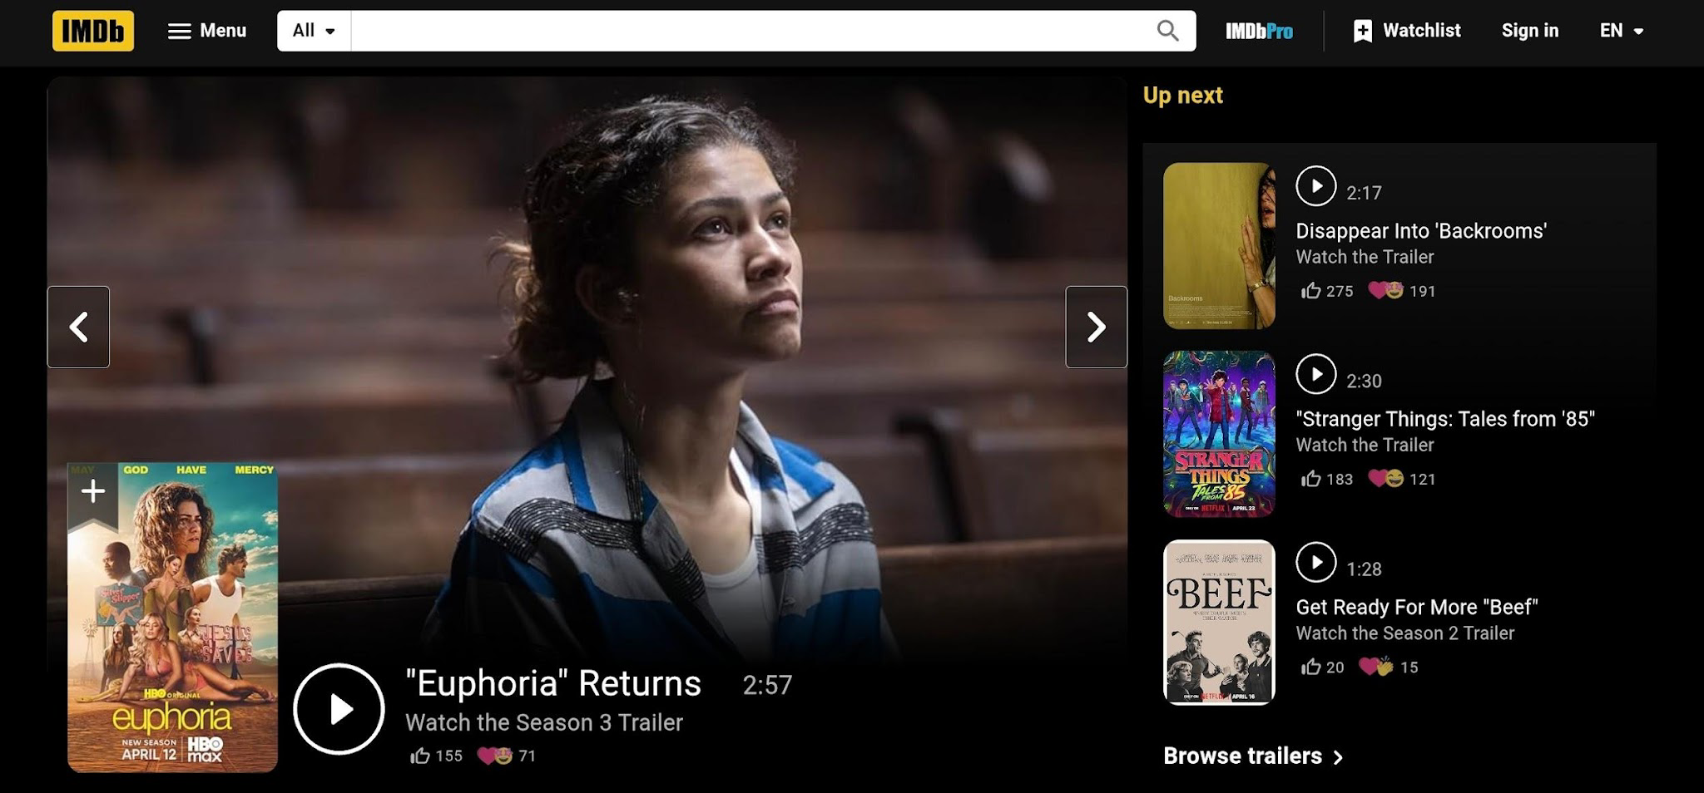
Indulekha (2026) defined IMDb as “a platform for those who watch films to come and talk about it”, and the wide range of opinions, interactions, reviews, and analyses contributed by users enhances the site’s depth, positioning it as a valuable platform for examining audience perception and broader interpretations of film culture. She also emphasized that regardless of whether these responses express admiration or criticism, the platform reflects the continuous circulation and exchange of viewers’ sentiments.
Figure 2 shows how IMDb allows users to see how others have rated the film with the star rating system from 1 to 10 and read different perspectives on the movie, ranging from brief reviews to detailed reviews. Users can also engage with these reviews by liking and disliking

Figure 2
IMDb’s user review page
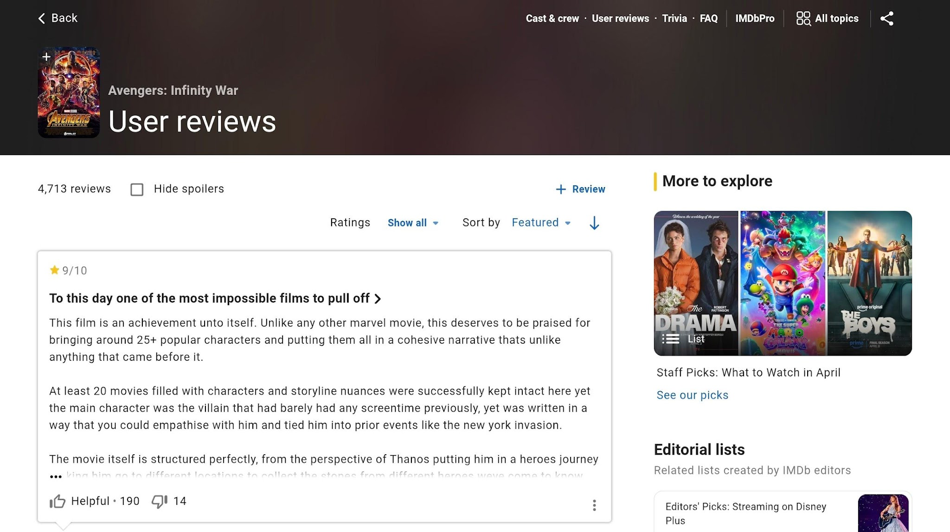
In addition, the platform provides features that allow users to sort reviews based on relevance, recency, and helpfulness, enabling readers to navigate large volumes of user-generated content. Each review is typically accompanied by a headline, the numerical rating, and a written commentary. Beyond these technical features, IMDb also functions as an interactive discursive space where users not only consume but also contribute to ongoing conversations about a film. The visibility of other users’ reactions, such as the number of “helpful” votes a review receives, further shapes how opinions are perceived and validated within the community. With these features, IMDb encourages users to articulate their thoughts and emotions in ways that resonate with a broader audience.

Affective Discourse Analysis (ADA)
The expression of affect occurs across all levels of the linguistic system. Foley (2011) defines affect as individuals' perceptions of their surroundings that pertain to linguistic tools used to convey emotions. When integrated with discourse, it then becomes concerned with the construction of emotions in language. Rooted from Sara Ahmed’s “affective economies”, Boler, Kweon, and Threasaigh (2024) in their study “Digital Affect Culture and the Logics of Melodrama: Online Polarization and the January 6 Capitol Riots through the Lens of Genre and Affective Discourse Analysis” coined and defined ADA as a multi-method approach to tracking and coding the social materiality of emotion through digital linguistic practices.
This framework departs from traditional discourse analysis by foregrounding emotion as a central analytic category rather than a peripheral element. At the same time, it addresses the limitations of computational sentiment analysis, which often reduces affect to simplistic positive or negative classifications. Affective Discourse Analysis conceptualizes emotion as socially constructed and discursively enacted, emphasizing its role in shaping meaning, identity, and power relations.
Digital affect culture refers to the patterned ways in which emotions are expressed, amplified, and normalized across online platforms. Within this concept, it is highlighted that emotions are not isolated or spontaneous; rather, they are shaped by the affordances of digital media, including mechanisms such as sharing, liking, and commenting. These affordances facilitate the rapid circulation of affect, allowing emotional expressions to spread widely and gain visibility. As a result, users are not only expressing their own feelings but are also participating in a broader system where emotional norms are collectively reinforced. In relation to this, Giaxoglou and Döveling (2018) emphasized that the emergence of the “affective turn” (Clough, 2008; Clough & Halley, 2007) and the “emotional turn” (Lemmings & Brooks, 2014), have led to the increase of the attention to emotion and affect across the humanities and social sciences, resulting in numerous calls for their empirical studies. Campbell, Smith, and Wetherell (2017) highlighted the necessity of empirically grounded research to better account for the complex, context-specific, and socially situated dynamics of affect and emotion, thereby challenging their reduction to merely pre-cognitive and pre-discursive constructs (cf. Massumi, 2002).
Building from these perspectives, these studies suggest that online film reviews function as discursive spaces where emotions such as nostalgia and grief are not only expressed but also constructed through language. Studies on digital discourse emphasize that emotional expressions are shaped by interactional dynamics, where users align or misalign with others through shared affective meanings. However, while previous studies have examined emotional engagement in media, there is limited research that focuses on the linguistic construction of nostalgia and grief in user-generated film reviews. This gap may be partly attributed to the relatively recent development of Affective Discourse Analysis as a framework, as well as to the more limited attention given to specific media contexts that evoke collective emotional responses and the patterned language through which audiences express them.

Statement of the Problem
While film criticism is a well-documented field, the specific linguistic mechanisms used to express nostalgia and grief in digital spaces remain underexplored. This study addresses the lack of formal discourse analysis on how these emotions are articulated by lay audiences on platforms like IMDb, seeking to uncover the linguistic patterns that define 'grieving' and 'nostalgic' digital testimonies. Generally, the study sought answers to the following questions:
- How may the affective lexical and evaluative features in the IMDb user reviews of Avengers: Endgame be classified and analyzed?
- How do recurrent lexical features function as affective practices in the construction and circulation of nostalgia and grief in IMDb user reviews of Avengers: Endgame?
- How do metaphors of ending function as affective resources, alongside lexical choices, in discursively framing nostalgia and grief following the narrative closure of Avengers: Endgame?

Research Framework
This study is anchored on how IMDb user-generated reviews are analyzed through two key analytical components: affective lexical and evaluative features, and metaphorical framing of ending. These components function as affective resources that contribute to the discursive construction of emotion, guided by the principles of Affective Discourse Analysis. The design is interpretive and discourse-oriented, focusing on identifying patterns of affective meaning rather than measuring frequency or sentiment.
Affective Discourse Analysis (ADA), as explained by Boler, Kweon, and Threasaigh (2024), sees emotions not only as internal feelings, but instead, they are produced, performed, and circulated through language and interaction. By combining discourse analysis with ethnographic and genre-based methods, ADA reveals how emotional expressions function as social practices that shape identities, narratives, and power relations in digital communication. A key concept within ADA is that of affective-discursive practice, which underscores the inseparability of language and emotion. From this perspective, discourse does not merely convey information but also performs and organizes affect. Emotional expressions are embedded in linguistic choices, rhetorical strategies, and narrative structures, thereby contributing to the construction of social realities.
This study only focused on the recurrent lexical choices and metaphors of ending that appear on the user-generated IMDb reviews of Avengers: Endgame. The analysis is based on the theory discussed. Figure 3 presents the modified conceptual model adapted from Boler, Kweon, and Threasaigh’s framework of Affective Discourse Analysis, with the integration of Appraisal Theory (Martin & White, 2005) and Margaret Wetherell’s framework of Affective Practice as theoretical foundations for identifying and interpreting affective lexical resources. For the analysis of metaphorical constructions, the study drew upon Lakoff and Johnson’s Conceptual Metaphor Theory.

Figure 3
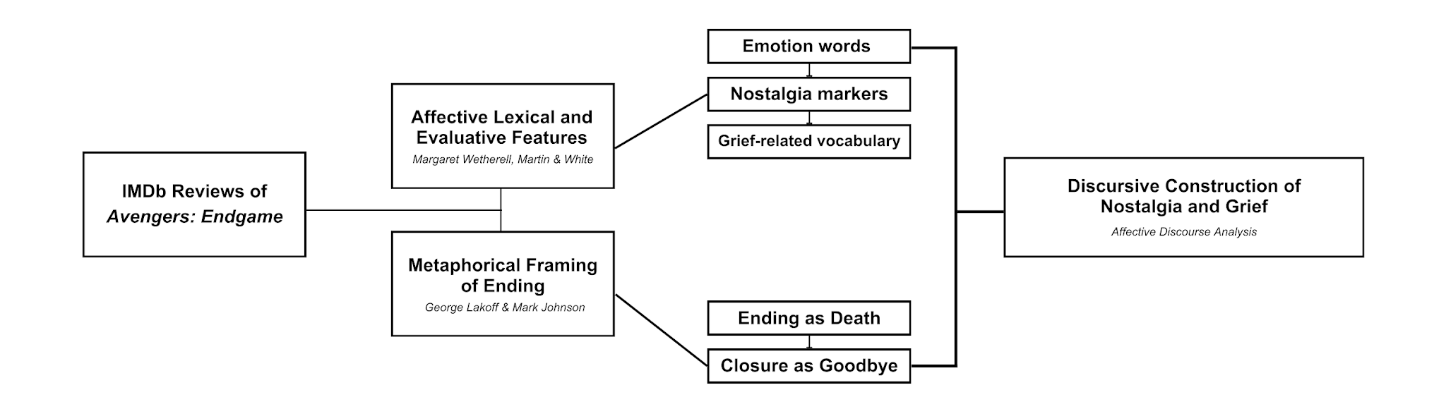
Conceptual framework of the study
Within this study, affective lexical and evaluative features are treated as central affective resources in the discursive construction of nostalgia and grief. Affective lexical features refer to words and expressions that encode emotional meanings, including both explicit emotion terms and more implicit or figurative expressions that evoke affect. Importantly, these lexical choices are not approached as transparent reflections of internal psychological states. Rather, they are understood as socially situated and patterned forms of expression that emerge within particular discursive contexts. Drawing on Margaret Wetherell’s concept of affective practices, these recurring lexical items are seen as part of ways of “doing emotion” in discourse. Additionally, the study also drew on J. R. Martin and Peter R. R. White’s Appraisal Theory, which provides a framework for analyzing evaluative language. Through this, affective lexical and evaluative features are examined as both structured linguistic elements and socially meaningful practices.
These affective lexical and evaluative features can further be divided into three types: emotion words, nostalgia markers, and grief-related vocabulary.

Figure 4
Categories of Affective Lexical and Evaluative Features
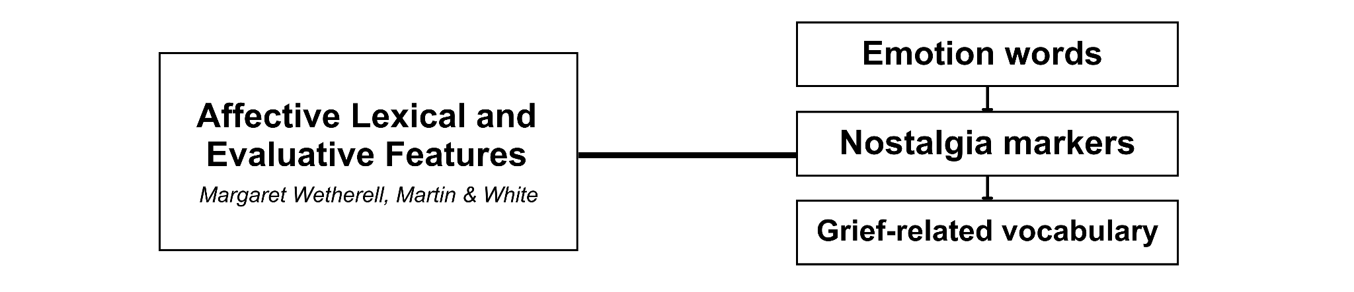
- Emotion words
Within Appraisal Theory, these fall under the category of affect, which captures how individuals linguistically express feelings and emotional responses. These words provide immediate insight into how reviewers experience and communicate their reactions to the film. For example, a user might review, The ending is heartbreaking, the word heartbreaking functions as an explicit marker of affect.
- Nostalgia markers
Nostalgia markers evoke the past, memory, and personal or collective history. These may include references to childhood, memories, growing up, or the beginning of the journey. While these expressions may not always explicitly name an emotion, they implicitly construct a nostalgic orientation by linking present evaluation with past experience. Within Wetherell’s framework, such markers can be understood as part of affective practices that connect individual memory to shared cultural narratives. For instance, phrases such as “a perfect ending to a decade-long journey” simultaneously encode emotional attachment and evaluative judgment, demonstrating how nostalgia operates through both affective and evaluative dimensions.

- Grief-related vocabulary
This consists of lexical items that explicitly or implicitly convey loss, separation, and emotional pain. Examples include words such as loss, goodbye, pain, devastated, and mourning. These terms reflect the affective dimension of grief. From the perspective of affective practices, grief-related vocabulary reveals how loss is collectively performed in digital discourse. The recurrence of such terms across reviews suggests that viewers are not only expressing personal grief but also participating in a shared cultural practice of mourning fictional characters, thereby reinforcing the social dimension of affect.

Figure 5
Metaphorical Framing of Ending based on Lakoff and Johnson’s Conceptual Metaphor Theory
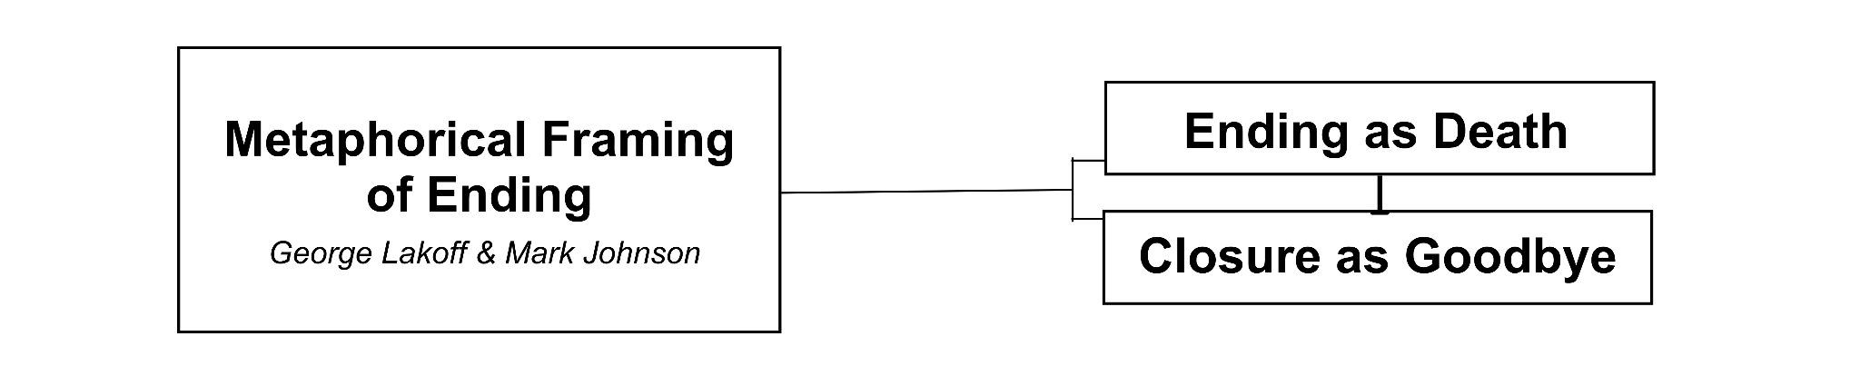
In addition to Martin and White’s Appraisal Theory and Wetherell’s Affective Practices, this study also integrates Lakoff and Johnson’s Conceptual Metaphor Theory (CMT), which explains that metaphors are understood as cognitive and linguistic mechanisms that structure how abstract experiences such as endings, loss, and closure are conceptualized. According to this theory, abstract concepts are often understood in terms of more concrete or embodied experiences. In the context of film reviews, the abstract notion of a narrative ending is frequently framed through metaphorical expressions that draw on domains such as death, departure, or farewell.
- Ending as Death
The metaphor Ending As Death conceptualizes the conclusion of a narrative as equivalent to the loss of life. This is evident in expressions such as “this movie killed me”, “it felt like losing someone”, or “the end of an era”. This metaphorical mapping intensifies the emotional weight of the film by aligning it with real-life experiences of grief. It also interacts with grief-related vocabulary, reinforcing the construction of the viewing experience as a form of symbolic mourning.
- Closure as Goodbye
The metaphor Closure as Goodbye frames the ending of the film as a form of farewell or parting. This is reflected in expressions such as “we’re going to miss these characters”. Unlike the metaphor of death, which emphasizes loss, this framing highlights the relational and transitional aspects of ending. Within this metaphor, closure is constructed as an emotional process that involves acknowledgment, acceptance, and release. From the perspective of CMT, this metaphor draws on embodied experiences of leave-taking and separation, making the abstract concept of narrative closure more tangible and emotionally resonant.

Significance of the Study
The aim of this study is to investigate the linguistic construction of nostalgia and grief in user-generated reviews of Avengers: Endgame in IMDb through Affective Discourse Analysis (ADA). The researcher seeks to contribute to the existing literature on film reviews and Discourse Analysis by applying Affective Discourse Analysis framework to analyze how users of IMDb use specific linguistic mechanisms to express nostalgia and grief in digital discursive spaces. The theoretical implications of this study are significant as it expands the application of ADA to the analysis of film reviews. Practically, the findings of this study may be valuable to filmmakers, critics, and scholars in both film and linguistic studies. By providing a systematic framework for analyzing audience responses, the study offers insight into how viewers interpret, evaluate, and emotionally engage with films, particularly those that carry strong themes of closure, loss, and nostalgia. This, in turn, may inform approaches to storytelling, audience reception analysis, and the broader understanding of affect in digital media discourse.
ELS Researchers. Academic researchers, particularly those in English Language Studies, may benefit from this study by gaining insights into how emotions are linguistically constructed in user-generated film reviews on platforms such as IMDb. By examining how viewers articulate nostalgia and grief through patterned lexical and evaluative features, this study contributes to the development of more refined, language-centered approaches in analyzing digital discourse. It also provides a useful reference for researchers interested in applying Affective Discourse Analysis to media-related texts, thereby expanding its empirical scope within linguistic studies.
Filmmakers. This research offers filmmakers valuable insights into how audiences emotionally engage with films, particularly in relation to themes of closure, loss, and nostalgia. By analyzing how viewers respond to Avengers: Endgame through their reviews, filmmakers can better understand how narrative endings, character arcs, and emotional payoffs are received and interpreted. Such insights may inform storytelling strategies and creative decisions aimed at enhancing audience connection and emotional impact.
Film Critics. This study will provide film critics with a framework for analyzing audience discourse in digital platforms such as IMDb. By examining how viewers construct and communicate their emotional responses, critics may refine their evaluative approaches and become more attuned to the affective dimensions of film reception. This may contribute to more evident and audience-aware forms of film criticism that bridge professional analysis and public engagement.
Viewers/Moviegoers. For viewers, this study encourages a more critical awareness of how emotions are expressed and interpreted in relation to films. By highlighting the role of linguistic choices in shaping affective responses, the study promotes deeper engagement with film discourse beyond surface-level reactions. It also underscores the significance of films as shared cultural experiences that evoke and circulate collective emotions within digital communities.

Scope and Limitations
This study focuses on the affective discourse analysis of user-generated film reviews of Avengers: Endgame posted on IMDb from April 2019 to December 2019. Specifically, it examines how nostalgia and grief are linguistically and discursively constructed through affective lexical and evaluative features, as well as metaphorical framings of ending. The dataset is limited to 30 selected IMDb user reviews that explicitly contain emotional expressions related to the film’s conclusion, character arcs, and overall narrative experience.
The analysis is confined to textual data and does not include other forms of multimodal content such as images, ratings, or user interaction metrics (e.g., likes or helpfulness votes). Additionally, the study does not consider demographic variables such as the reviewers’ nationality, age, or background, as the focus is placed on language use rather than user identity. Reviews written in languages other than English are also excluded to maintain consistency in linguistic analysis.
The study concentrates on specific linguistic features, namely affective lexical choices, evaluative expressions based on Appraisal Theory and Affective Practices, and metaphors of ending grounded in Conceptual Metaphor Theory. Other aspects of film analysis, such as narrative structure, cinematography, or genre conventions, are not examined, as they fall outside the primary focus on discourse and language. Lastly, due to the qualitative and interpretive nature of the analysis, the findings of this study are not intended to be generalized to all film reviews or audiences. Rather, they provide an in-depth understanding of how nostalgia and grief are constructed within a specific digital context, offering insights into broader patterns of affect in film discourse.

Definition of Terms
The following terms are defined both conceptually and operationally to provide clarity and facilitate a better understanding of the key concepts used in this study.
Affect. A subsystem of attitude in Martin and White’s Appraisal Theory which refers to the linguistic expression of emotional responses to certain occurrences.
Affective Discourse Analysis (ADA). A multi-method analytical framework that evaluates how emotions are constructed and circulated through language in discourse.
Affective Lexical and Evaluative Features. The emotionally charged words, evaluative adjectives, and expressive phrasing that function as carriers of affect within discourse. In this study these are words and expressions that encode emotional and evaluative meaning, categorized as emotion words, nostalgia markers, and grief-related vocabulary.
Affective Practices. A theoretical framework developed by Margaret Wetherell referring to the ways in which emotions are produced and performed socially through discourse.
Affective Resources. The linguistic elements through which emotions are expressed and constructed in communication.
Affective Verbs. Verbs that explicitly express emotional states or responses towards an object, event, or experience.
Appraisal Theory. A framework within Systemic Functional Linguistics that analyzes how language expresses attitude and stance.
Conceptual Metaphor Theory (CMT). A theoretical framework by George Lakoff and Mark Johnson which expounds how abstract concepts are perceived through metaphorical mappings based on concrete human experience.
Discursive. A term that is used to describe the ways in which emotions are constructed, organized, and communicated through language within a specific social context.
Evaluative Adjectives. Descriptive words that express a speaker’s assessment toward a particular object, event, or experience that assign value and emotional significance to them.
IMDb (Internet Movie Database). A website and application where users rate and review films and television shows.
Intensifiers. Linguistic elements that amplify the intensity of an emotional expression.
Marvel Cinematic Universe (MCU). A shared fictional universe of interconnected superhero films and television series produced by Marvel Studios characterised by a continuous narrative structure where individual films contribute to a larger storyline.
Temporal Markers. Are words or phrases that imply the time of a certain experience that link present emotional responses to the past

METHODOLOGY

This section discusses the methodology to be employed in the study, focusing on the research context, design, process, and its corpus used. It includes an explanation of how data collection will be conducted.

Research Context
This study is situated within the field of discourse analysis, with particular emphasis on user-generated film reviews in online review platforms. It examines how emotions are constructed, articulated, and circulated through language in digital environments, specifically within IMDb (Internet Movie Database), a widely recognized online database that facilitates user interaction through film reviews and ratings. As an interactive discursive space, IMDb enables users to express subjective evaluations and emotional responses to films, thereby functioning as a site where these emotions are shared. While other websites and applications offer similar functionalities, IMDb remains distinctive because of its established credibility and its role as a centralized source of film-related information.
With the continuous development of digital platforms, IMDb has sustained a strong global presence, supported by millions of users who actively contribute to its expanding collection of reviews and discussions. This growth underscores the increasing significance of online environments in shaping film discourse, where personal experiences and emotional engagement are central. Films with substantial narrative impact, such as Avengers: Endgame (2019), often generate a high volume of audience responses that go beyond simple evaluation and include expressions of nostalgia and grief.
Therefore, this study is driven by the growing role of digital platforms in influencing audience discourse and the limited research that explores the linguistic construction of emotion in user-generated film reviews. By examining IMDb reviews of Avengers: Endgame, the study aims to contribute to a deeper understanding of how nostalgia and grief are expressed through language in digital contexts.

Research Design
This study employed a qualitative research methodology to systematically examine how users express nostalgia and grief in IMDb reviews of Avengers: Endgame (2019). The selected research design allows for the analysis of textual data, particularly user-generated reviews, as a means of understanding how emotions are constructed through language. To evaluate how viewers articulate their emotional responses to the film, this study focused on analyzing written reviews from IMDb. These reviews serve as primary data, providing insight into how users linguistically construct affective experiences such as nostalgia and grief within a digital environment. The emphasis is placed on interpreting patterns of meaning embedded in discourse rather than quantifying responses. The sampling technique used in this study is purposive sampling as this method is particularly valued for exploring complex phenomena in depth (Tajik et al, 2024). Through this approach, the researcher carefully selects reviews that contain relevant emotional expressions, ensuring that the data to be collected provides sufficient depth and context for analysis.

Research Process
The users’ reviews on IMDb are analyzed using Boler, Kweon, and Threasaigh’s Affective Discourse Analysis following these steps:
First, data selection is carried out by identifying user-generated reviews of Avengers: Endgame from IMDb. Reviews are chosen based on their relevance to the study, particularly those that contain expressions of nostalgia and grief.
Second, purposive sampling is employed to select a total of thirty (30) reviews that meet the inclusion criteria. These criteria include: (a) reviews written in pure English only, (b) reviews published between April 2019 and December 2019, and (c) reviews containing explicit or implicit emotional expressions related to the film’s ending, character arcs, or narrative closure.
Third, data collection involves manually compiling the selected reviews into a dataset. Only the textual components of the reviews are included, while non-textual elements such as numerical ratings, user demographics, and interaction metrics are excluded.
The fourth stage is coding of affective lexical and evaluative features, guided by Appraisal Theory and the concept of affective practices. In this phase, the researcher identifies and categorizes lexical items into emotion words, nostalgia markers, and grief-related vocabulary. This categorization is presented in a table format for easier reference.
The fifth stage involves identification of metaphorical expressions, based on Conceptual Metaphor Theory. The researcher analyses how abstract concepts such as endings and closure are framed through metaphorical language, particularly Ending as Death and Closure as Goodbye. This is also presented in a table format for easier reference.
The sixth stage is discursive interpretation, where the coded lexical and metaphorical features are grouped together according to their lexical field and are analyzed in relation to their functions within the review. The researcher examined how these linguistic elements operate as affective-discursive practices, contributing to the construction and circulation of nostalgia and grief.
The final stage is synthesis and interpretation of findings, wherein the researcher integrates the results of the analysis to address the research questions. These procedures ensured that the study maintained ethical standards in both data collection and analysis, thereby supporting the credibility and reliability of its findings.

Corpus of the Study
For this study, the corpus consists of user-generated reviews from IMDb regarding the film Avengers: Endgame (2019). The reviews are collected from a specific period, spanning April 2019 to December 2019, in order to capture viewers’ immediate and sustained emotional responses following the film’s release. This timeframe was selected to ensure that the data reflects audience reactions during the height of the film’s cultural impact and narrative relevance.
To facilitate an in-depth qualitative analysis, the researcher gathered a total of thirty (30) reviews. The selection of reviews is guided by purposive sampling, focusing on entries that contain explicit or implicit expressions of nostalgia and grief. After that, the researcher utilized the fish bowl method for choosing the final thirty (30) reviews for analysis. The criteria for selecting the reviews include the following: (1) reviews must be written in pure English, (2) reviews must contain emotional expressions related to the film’s ending, character arcs, or overall narrative experience, (3) reviews must contain sufficient textual content for the analysis, operationalized as at least one complete sentence or approximately 20–30 words, and (4) each review must include at least one identifiable affective or evaluative feature and/or a metaphorical expression related to endings, loss, or closure.
The study focuses on reviews that articulate personal reflections, emotional reactions, and evaluative judgments about the film, as these provide a rich source of linguistic data for Affective Discourse Analysis. Particular attention is given to reviews that demonstrate the use of emotion words, nostalgia markers, grief-related vocabulary, and metaphorical framings of ending, as these elements are central to the analytical framework of the study. To maintain consistency and analytical clarity, only the textual components of the reviews are to be included in the corpus. Non-textual elements such as numerical ratings, helpfulness votes, and user demographic information were excluded from the analysis. Each review is treated as an individual unit of analysis, allowing for a detailed examination of how affective meanings are constructed and communicated through language.

RESULTS AND DISCUSSION

This section presents the results and discussion of the affective discourse analysis of nostalgia and grief in the selected IMDb user reviews of Avengers: Endgame. The findings are organized according to recurrent linguistic and discursive patterns identified across the corpus. The analysis of affective lexical and evaluative features revealed four major themes: (1) Nostalgia Through Temporal and Collective Memory, (2) Grief Through Expressions of Loss and Separation, (3) Emotional Intensification Through Evaluation and Embodiment, and (4) Shared Fanbase Identity. These themes address the classification of recurrent linguistic resources and their functions as affective practices in the construction and circulation of nostalgia and grief. The section subsequently examines the metaphorical framing of ending through the conceptualizations Closure as Goodbye and Ending as Death.
Within the corpus, recurrent linguistic patterns function as affective practices through which reviewers construct and negotiate nostalgia and grief in response to the narrative closure of Avengers: Endgame. These patterns are realized through temporal references, acts of remembering, references to childhood and beginnings, expressions of death and sacrifice, farewell and separation, embodied emotional pain, evaluative intensification, and markers of shared fan identity. Examining these recurrent forms reveals how reviewers draw on personal and collective memory, sustained emotional attachment, experiences of loss, and communal identification to make the ending of the Infinity Saga affectively meaningful. The chapter concludes by synthesizing these findings and discussing how the identified lexical and metaphorical patterns collectively contribute to the discursive construction of nostalgia and grief across the reviews.

- Affective Lexical and Evaluative Features
The first part of the analysis examines the affective lexical and evaluative features identified in the corpus. These are classified as temporal markers, emotion words, evaluative features, and grief-related vocabulary, and analyzed according to their immediate functions in expressing emotion, evoking past experiences, assigning value, and articulating loss and separation.
Table 1 presents the classification and functions of the affective lexical and evaluative features identified in the selected IMDb reviews of Avengers: Endgame.
Table 1
Classification and Functions of Affective Lexical and Evaluative Features
Lexical Features | Classification | Discursive Function
over a decade ago; a decade of Marvel content; from the start; past ten years; 11 years later; since day one; since 2008 | temporal marker — nostalgia marker | Establishes the temporal relationship between the reviewer’s present response and their earlier or prolonged engagement with Marvel
the good ol’ days; think back to the old times of Avengers; remember vividly how this all started; We remember; always cherish this movie and memory | temporal marker — nostalgia marker | Connects the present experience of Endgame with remembered past experiences associated with the MCU
Table 1
Continuation
grew up with and lived through the Marvel Age of Comics; at 12 years old; relive my childhood; back in elementary school; characters I’ve grown up with | temporal marker — nostalgia marker | Locates engagement with Marvel within earlier stages of the reviewer’s personal history
feel connected; long-known friends; privileged; amazed and delighted; touching moments; emotional moments make you feel; heavily invested emotionally | affect — emotion words | Expresses the reviewer’s emotional attachment, involvement, or response toward the film, characters, or franchise
tearful; sad; a little depressed; heartbreaking; gut wrenching; had me in tears; I cried; burst into tears | affect — emotion words | Expresses emotional distress, sadness, or pain associated with events and closure in the film
sad and happy; cry and laugh; mixed emotions | affect — emotion words | Expresses the coexistence of contrasting emotional responses to the film’s conclusion
so much emotion; emotionally moving; emotionally surreal experience; hit right in the feels | affect — emotion words | Presents emotional intensity as a defining aspect of the viewing experience
beloved characters; faith in this belief irrefutably validated | evaluative feature / affect — emotion words / positive evaluation | Assigns emotional and positive value to the characters or to the reviewer’s experience of the franchise
beautiful ending; perfect end; great end; wonderful experience; greatest three hours of my life; one of the most iconic groups | evaluative feature — positive evaluation | Positively evaluates the film, its conclusion, characters, or overall cinematic experience
Table 1
Continuation
hard to say goodbye; Goodbye the original Avengers; I love you 3000 Tony | affect — grief-related vocabulary | Expresses emotional leave-taking and attachment in response to character or narrative departure
sacrifice themselves for their teammates; gave her life; gave his life for the future; sadly lost and may never see again; lost everything | grief-related vocabulary | Constructs death, sacrifice, absence, and loss as emotionally significant experiences
a real life loved one has died; showing how losing everyone affected them; left me in tears | grief-related vocabulary | Represents loss and mourning through explicit references to bereavement and its emotional consequences

Based on the individual analysis of the reviews, the linguistic expressions were classified according to their form and affective category. These include temporal markers categorized as nostalgia markers, affective expressions categorized as emotion words, evaluative features expressing positive evaluation, and expressions categorized as grief-related vocabulary. Nostalgia and grief emerge in the reviews through a range of linguistic resources, including explicit emotion words, temporal references, evaluative language, and expressions of loss and separation.
Temporal markers classified as nostalgia markers include expressions such as over a decade ago, past ten years, 11 years later, since 2008, the good ol’ days, and remember vividly how this all started. These features establish temporal relationships between the reviewers’ present responses to Avengers: Endgame and earlier periods of engagement with the Marvel Cinematic Universe. Some expressions emphasize the duration of engagement, while others refer to past experiences, childhood, or the beginning of the franchise. Their primary function is therefore to locate the emotional significance of the film within a longer personal or cinematic history. In this classification, nostalgia is linguistically indicated by references that direct attention from the present moment of viewing toward an emotionally significant past.
The reviews also contain affective expressions classified as emotion words. These include expressions such as feel connected, privileged, sad, depressed, heartbreaking, had me in tears, amazed and delighted, and mixed emotions. Unlike temporal markers, these expressions directly communicate the reviewers’ emotional responses toward the film, its characters, or its conclusion. Positive emotion words express attachment, admiration, satisfaction, and emotional involvement, while negative emotion words communicate sadness, distress, and emotional pain. Expressions such as mixed emotions, sad and happy, and cry and laugh additionally demonstrate that emotional responses to the film may contain contrasting affects within the same review. Thus, emotion words function primarily by making the reviewer’s affective stance toward the film explicitly recognizable.
Another classification identified in the reviews consists of evaluative features, particularly expressions of positive evaluation. Terms and phrases such as beautiful ending, perfect end, great end, wonderful experience, and greatest three hours of my life assign value to the film and its ending. Rather than simply naming an emotional state, these features communicate the reviewer’s judgment or assessment of the film. Their function is to positively evaluate Avengers: Endgame, its characters, or the manner in which the Infinity Saga is concluded. In some instances, evaluation and affect overlap, as expressions such as beloved characters simultaneously assign positive value to the characters and communicate emotional attachment toward them. This reflects the interaction between affective and evaluative meaning in the reviewers’ language.
Finally, grief-related vocabulary includes expressions such as hard to say goodbye, sadly lost, gave her life, sacrifice themselves, may never see again, and a real life loved one has died. These expressions linguistically construct grief through references to death, sacrifice, loss, farewell, absence, and emotional separation. Their immediate function is to identify either the source of grief or the emotional consequences associated with the film’s conclusion. Expressions referring to death and sacrifice foreground the loss of characters, while farewell expressions such as hard to say goodbye emphasize emotional separation. In this way, grief-related vocabulary provides explicit linguistic resources through which reviewers communicate the affective significance of character departures and narrative closure.
These classifications show that the affective construction of nostalgia and grief in the reviews is realized through different but interconnected linguistic resources. Temporal markers establish connections between the present and the past; emotion words directly encode emotional responses; evaluative features assign positive or emotional value to the film and its characters; and grief-related vocabulary show experiences of loss, death, farewell, and separation. Therefore, the affective lexical and evaluative features may be classified according to their linguistic and affective functions as temporal markers associated with nostalgia, affective expressions functioning as emotion words, evaluative features expressing judgment or appreciation, and grief-related vocabulary associated with loss and separation. These classifications provide the lexical foundation for the subsequent examination of how such features operate as recurrent affective practices.
Having identified and classified the affective lexical and evaluative features and their immediate functions, the analysis now moves from individual linguistic features to their recurrence across the corpus.
II. Recurrent Lexical Features as Affective Practices of Nostalgia and Grief
This subsection examines how observed recurrent lexical patterns function as affective practices in constructing and circulating nostalgia and grief. The identified features are organized into three themes: Nostalgia Through Temporal and Collective Memory, Grief Through Expressions of Loss and Separation, and Shared Fanbase Identity. Together, these themes show how reviewers draw on temporal references, memories, evaluative language, embodied reactions, expressions of loss, and collective identification to construct and circulate affect in relation to the film’s narrative closure.
Table 2 summarizes the recurrent lexical patterns identified across the corpus and their organization into three broader themes. These patterns provide the basis for examining how recurrent lexical features function as affective practices in the construction and circulation of nostalgia and grief.
Table 2
Summary of Recurrent Lexical Patterns and Subthemes
 | Recurrent Lexical Pattern | Subthemes
1 | Nostalgia Through Temporal and Collective Memory | Temporal References  Memory References to Childhood  Recollection of Beginnings
2 | Grief Through Expressions of Loss and Separation | Death and Sacrificial Loss  Farewell and Irreversible Separation  Mourning and Embodied Emotional Pain

Table 2
Continuation
3 | Shared Fanbase Identity | Collective PronounsGratitude and AppreciationFan Identity and Self-PositioningAudience Address and Participatory Invitations

Table 2 summarizes the recurrent lexical patterns identified across the corpus and the subthemes through which each pattern is realized. The patterns are organized into three broader areas: Nostalgia Through Temporal and Collective Memory, Grief Through Expressions of Loss and Separation, and Shared Fanbase Identity. Their corresponding subthemes specify the particular forms through which these patterns emerge in the reviews, including temporal reference, memory, childhood, loss, farewell, embodied emotion, collective identification, gratitude, fan positioning, and audience address. Each recurrent lexical pattern and its subthemes are discussed in detail in the succeeding subsections, where their functions as affective practices in the construction and circulation of nostalgia and grief are examined.

Nostalgia Through Temporal and Collective Memory
One of the most prominent patterns identified across the corpus is the recurrent use of temporal markers that connect the experience of watching Avengers: Endgame with earlier periods in the reviewers’ personal and collective histories. These expressions frequently refer to the passage of time, the beginning of the Marvel Cinematic Universe, childhood experiences, and long-term engagement with the franchise. Through such references, reviewers situate the film’s conclusion within a broader temporal context, linking the present experience of Avengers: Endgame to memories and experiences accumulated over several years. This recurring pattern demonstrates how nostalgia is linguistically constructed through references to time, memory, and continuity across the corpus.
Table 2.1 presents the recurrent temporal and memory-related linguistic features identified across the corpus, illustrating how reviewers construct nostalgia through references to the passage of time, personal memories, childhood experiences, and shared histories of engagement with the Marvel Cinematic Universe.

Table 2.1
Lexical Features of Nostalgia Through Temporal and Collective Memory
Subtheme | Recurrent Pattern | Lexical Features | Affective-Discursive Function
1 | Temporal References | over a decade ago; a little under eleven years; past ten years; 11 years later; nearly 11 years later; last 10 years and 23 movies; since day one, since 2008 | Temporal positioning: Situates reviewers’ present responses within their prolonged engagement with the MCU.
2 | Memory | beautiful memories; I’ll always remember; remember the scenes; we remember; the good ol’ days; always cherish this movie and memory; think back to the old times of Avengers, will be remembered for the rest of however long superhero and action movies continue to be made; unforgettable one | Recollection and preservation: Reconstructs past experiences in the present while sustaining their emotional significance.
3 | References to Childhood | at 12 years old; relive my childhood; my childhood; back in elementary school; in my youth; the characters I’ve grown up with; grew up with and lived through the Marvel Age of Comics | Autobiographical positioning: Reviewers incorporate the MCU into narratives of personal development and identity.

Table 2.1
Continuation

4 | Recollection of Beginnings | the first Iron Man movie; from the start; back in 2008; started it all; began in 2008 with Iron Man; way back when Iron Man 1 came out; remember vividly how this all started, fans have been waiting for since 2008 | Retrospective reconstruction: Reviewers return discursively to the perceived origin of either the MCU or their own involvement with it.

Table 2.1 foregrounds a recurrent nostalgic alignment across the corpus, themed through four interrelated subthemes: temporal references, memory, references to childhood, and recollection of beginnings. Taken together, these linguistic features position the reviewers’ responses to Avengers: Endgame within a layered temporal frame by relating the present moment of narrative closure to earlier periods of engagement with the Marvel Cinematic Universe. The ending is therefore not constructed as a self-contained cinematic event, but as the culmination of an extended history of attachment shaped by years of viewing, remembered experiences, formative stages of life, and points of origin within the Marvel Cinematic Universe.
The first subtheme is analyzed through recurrent temporal expressions that mark elapsed time, duration, and continuity between past and present. In Review Extract 1, the phrase over a decade ago locates the beginning of the Infinity Saga at a considerable temporal distance from the present moment of Avengers: Endgame. Rather than referring to a specific remembered event, the expression foregrounds the length of time separating the beginning and conclusion of the saga, making it appropriately classified as a temporal reference. Similarly, Review Extract 2 used a little under eleven years to quantify the period between the reviewer’s first encounter with Iron Man and the release of Avengers: Endgame. The explicit measurement of elapsed time establishes a chronological span across which the reviewer’s engagement with the MCU has developed.
Comparable constructions recur elsewhere in the corpus. Review Extract 6 contains past ten years and fruit of ten years of hard work, both of which foreground the decade-long development of the franchise. Review Extract 13 similarly contrasts back in 2008 with 11 years later, while Review Extract 20 uses nearly 11 years later and throughout these past 11 years and 22 movies. Review Extract 21 likewise refers to the last 10 years and 23 movies, explicitly presenting the characters’ development and the audience’s attachment as having accumulated across an extended period.
Temporal references thus serve two interrelated affective-discursive functions. First, they legitimize and substantiate emotional attachment by representing the reviewers’ affective investment as cumulative, sustained, and historically grounded rather than immediate or incidental. Second, they construct temporal continuity between past and present, allowing contemporary responses to Avengers: Endgame to be interpreted in relation to the extended history of engagement that precedes them. From the perspective of affective practices, nostalgia is therefore produced through the temporal organization of experience: reviewers retrospectively position the moment of closure within a longer trajectory of fandom, thereby rendering the present affectively inseparable from the years, memories, and attachments accumulated across that trajectory.
The second subtheme is characterized by linguistic features that explicitly encode acts of remembering, recalling, preserving, or looking back on past experience. In Review Extract 5, beautiful memories directly nominalizes past experiences as memories, while I’ll always remember explicitly uses the verb remember to project those experiences beyond the immediate moment of the review. The adjective beautiful also evaluates those memories positively, indicating that what is being recalled is not neutral information but a valued past experience. In Review Extract 8, remember the scenes similarly uses the verb remember to represent the act of mentally returning to previous moments from the film. Memory becomes more explicitly retrospective in expressions such as the good ol’ days in Review Extract 3. The expression does not simply designate an earlier time; the evaluative phrase good ol’ constructs that earlier period as positively remembered and emotionally preferable. Review Extract 29 likewise uses think back to the old times of Avengers, in which the phrasal verb think back explicitly directs attention toward an earlier stage of the franchise. Review Extract 17 further develops this pattern through remember vividly how this all started and We remember, making remembering an explicit discursive act. Therefore, reviewers produce nostalgia by selecting particular past experiences and making them emotionally relevant again in the present.
The third subtheme consists of linguistic features that explicitly position Marvel within childhood, youth, or other formative stages of the reviewer’s life. These references differ from general memory expressions because they identify a specific biographical period through which attachment to the franchise is constructed.
Review Extract 5 contains the expression at 12 years old, accompanied by the image of a little girl’s dream. These expressions locate the reviewer’s relationship with Marvel within childhood by specifying both age and a child identity. Review Extract 13 provides even more explicit examples through relive my childhood and doing justice to my childhood. The noun childhood directly identifies the life stage being recalled, while the verb relive indicates the re-experiencing of that earlier period through the franchise. Review Extract 25 similarly states back in elementary school and later refers to the characters I’ve grown up with. The first expression situates the beginning of fandom within a recognizable formative stage, while grown up with linguistically connects the reviewer’s own aging to continued engagement with Marvel characters. Review Extract 17 extends this pattern through grew up with and lived through the Marvel Age of Comics and the reference to what the Marvel experience could be in my youth.
Reviewers organize emotion by placing the Marvel Cinematic Universe within narratives of their own life stages. In doing so, the ending of the Infinity Saga signifies distance from childhood or the completion of a period through which the reviewer has personally grown. Nostalgia is therefore constructed through the connection between media history and life history.
The fourth subtheme comprises expressions that specifically return to origins, first encounters, and starting points. Although these linguistic features may contain temporal or memory markers, their defining function is the reconstruction of where either the MCU or the reviewer’s relationship with it began.
Review Extract 2 refers to the first Iron Man movie, identifying the inaugural film as the reviewer’s initial point of engagement with the franchise. Similarly, Review Extract 7 uses from the start, and in Review Extract 13, I started this journey watching Iron Man 1 back in 2008 combines the verb started with the original Iron Man film and the year 2008, explicitly reconstructing a point of origin. This pattern is also evident in Review Extract 16 through started it all and the same words he said at the end of his first movie. The expressions link Tony Stark’s final moments back to his first appearance, establishing a discursive connection between origin and conclusion. Review Extract 18 similarly identifies the Marvel series as having began in 2008 with Iron Man, while Review Extract 20 states I remember way back when Iron Man 1 came out. Review Extract 17 reflect the same pattern through remember vividly how this all started.
Reviewers make the emotional impact of Avengers: Endgame intelligible by placing the ending in relation to a remembered beginning. The contrast between expressions such as started or began and the present experience of closure creates a beginning–ending structure through which the entire period between them becomes affectively meaningful. In this way, nostalgia is performed by returning to the origin and reassessing it from the perspective of the ending.
Viewed through Wetherell’s Affective Practices, these patterns show that nostalgia is not only stated as an internal feeling but performed through patterned acts of temporal positioning, remembering, autobiographical reconstruction, and retrospective return to origins. By situating Avengers: Endgame within longer histories of fandom and personal experience, reviewers legitimize their emotional attachment, preserve their memories, and make the film’s ending intelligible in relation to the years that preceded it. Nostalgia therefore emerges as a socially recognizable affective-discursive practice in which the past is repeatedly mobilized to give emotional significance to the present moment of closure.
Grief Through Expressions of Loss and Separation
Another prominent pattern identified across the corpus is the recurrent use of grief-related expressions that frame the conclusion of Avengers: Endgame through experiences of loss and separation. These expressions frequently refer to character death and sacrifice, acts of farewell and parting, anticipated or permanent absence, and emotional pain manifested through sadness, heartbreak, crying, and tears. Through such linguistic features, reviewers construct the film’s conclusion as the loss of characters and relationships to which they had developed sustained emotional attachment. This recurring pattern demonstrates how grief is linguistically constructed across the corpus through references to death and sacrificial loss, farewell and irreversible separation, and mourning and embodied emotional pain.
Table 2.2 presents the recurrent linguistic features through which grief is constructed across the corpus.
Table 2.2
Lexical Features of Grief Through Expressions of Loss and Separation
Subtheme | Recurrent Pattern | Lexical Features | Affective-Discursive Function
1 | Death and Sacrificial Loss | sacrificing their lives; Tony Stark died; a real life loved one has died; sacrifice themselves for their teammates; sadly lost; gave her life; he gave his life for the future; killing himself | Mourning through the recognition of death and sacrifice: Constructs character deaths as emotionally significant losses rather than simple narrative events.
2 | Farewell and Irreversible Separation | hard to say goodbye; emotional goodbye; Bye Bye! We’ll never see you again!; grand send-off; last time that some characters would ever interact; miss Chris in that role so much; move on without Avengers; Goodbye the original Avengers; sad to see it end | Leave-taking: Acknowledges and negotiates emotional separation from long-established MCU characters and relationships.

3 | Mourning and Embodied Emotional Pain | heartbreak; heartbreaking; I cried; still crying; burst into tears; left me in tears; weep; gut-wrenching; broken; rips your heart out; sorrows, pain; sad; depressed | Embodied mourning: Makes the emotional consequences of loss recognizable through linguistic and physical expressions.

The first subtheme consists of recurrent lexical items that explicitly denote death, loss of life, and voluntary self-sacrifice. These expressions are distinguished by verbs and nominal constructions such as died, killed, sacrifice, gave her life, gave his life, and lost, which directly identify death as the source of grief rather than merely implying sadness or separation.
In Review Extract 11, the phrases sacrificing their lives in the end and sacrifice herself foreground the deaths of the heroes as deliberate acts of self-sacrifice. The verb sacrifice, as analyzed, does not represent death as accidental or incidental to the narrative; rather, it constructs the loss as willingly undertaken for the benefit of others. The same review describes the heroes as brave and sacrificial, further evaluating sacrifice as an emotionally and morally meaningful action. A similar pattern is evident in Review Extract 16, where the reviewer states that “two of our beloved characters were killed off and that both of them sacrifice themselves for their teammates. The verb phrase killed off explicitly marks death and narrative finality, while sacrifice themselves frames those deaths in relational terms by identifying the beneficiaries of the sacrifice as their teammates. The later statement that Black Widow and Iron Man were sadly lost further shifts the linguistic framing from the event of death itself to the experience of losing valued figures.
Review Extract 22 contains an especially concentrated set of loss-related expressions. The reviewer states that Thor had lost everything, that his family, his friend, half of his people were gone, and that sadly we lost 3 of the most important members. The repetition of lost and gone constructs death and absence through a lexical field of deprivation. The same review describes Natasha as having gave her life and Tony as giving his life for the future, both of which linguistically construe death as self-sacrifice. Review Extract 23 similarly refers to Tony Stark as a hero who sacrificed his life for the survival of mankind and to Natasha as sacrificing herself for the better good. These expressions contain lexical choices that explicitly connect death with voluntary surrender of life, thereby constructing sacrifice as a meaningful form of loss rather than simply recording that a character has died.
The repeated pairing of death with sacrifice gives loss a relational dimension: characters are represented as dying for teammates, family, humanity, or the future. Within Affective Practices Theory, such formulations function as a patterned practice of mourning in which death is narrated not only as a plot event but as the meaningful loss of an emotionally valued figure.
The second subtheme is characterized by linguistic expressions that mark parting, anticipated absence, and the recognition that a relationship or period cannot continue in its previous form. Its primary lexical indicators include goodbye, never see again, last time, miss, move on, and similar constructions of farewell and separation.
One of the clearest examples occurs in Review Extract 1 through the phrase hard to say goodbye to so many beloved characters. The verb phrase say goodbye explicitly performs an act of farewell, while the adjective hard evaluates that separation as emotionally difficult. The reference to beloved characters also establishes why the goodbye carries affective weight: separation occurs from figures toward whom attachment has already been constructed. Review Extract 6 similarly describes Avengers: Endgame as a tearful, emotional goodbye to established characters. Here, goodbye directly signifies parting, while the modifiers tearful and emotional intensify the affective character of that separation. Review Extract 10 makes the finality even more explicit in the statement Bye Bye! We’ll never see you again! The farewell expression Bye Bye is immediately followed by never, a temporal absolute that constructs the separation as permanent.
Irreversibility is likewise encoded in Review Extract 18 through the last time that some of the characters would ever interact. The combination of last time and ever closes off the possibility of future interaction which foregrounds anticipated absence before the separation has even fully occurred. The construction of grief is oriented toward anticipated absence, as the reviewer’s sadness emerges from the recognition that the characters’ interactions have reached a point of finality and cannot be repeated.
Review Extract 16 combines several forms of separation language. The phrase sadly lost and may never see again joins loss with anticipated permanence, while I’m going to miss Chris in that role so much uses the affective verb miss to project emotional absence into the future. The same review concludes that all that’s left to do is to say goodbye to this era of the MCU, explicitly representing closure as an act of leave-taking.
Review Extract 19 develops separation through the imperative idea of having to move on without Avengers. The phrasal verb move on signals transition away from an established attachment, while without Avengers specifies the absence that must now be negotiated. Review Extract 24 similarly states Goodbye the original Avengers, followed by you will be forever alive in my heart. The first clause enacts separation, while the second attempts to maintain affective attachment despite that farewell.
In comparison, terms such as goodbye, never, last time, miss, and move on do not necessarily denote death; instead, they foreground the relational consequence of closure or the inability to continue encountering characters, relationships, or an established era in the same way. These recurrent expressions constitute a practice of leave-taking, through which reviewers discursively acknowledge attachment while simultaneously negotiating the necessity of separation.
The third subtheme is realized through lexical and phrasal constructions that represent grief as emotional suffering and bodily response. Unlike death vocabulary, which identifies the loss, or farewell expressions, which mark separation, these features foreground what the experience of loss does to the reviewer. Common linguistic realizations include heartbreaking, crying, tears, weep, broken, pain, trembling, silent, and stunned.
Review Extract 5, for instance, uses I’m still crying and break my heart. The progressive construction still crying is significant because still represents the emotional response as continuing beyond the immediate viewing experience. The expression break my heart, meanwhile, conceptualizes emotional suffering through physical damage to the heart, intensifying the representation of grief.
Review Extract 8 contains an especially dense cluster of embodied grief expressions. The reviewer states that the movie left me broken, that remembering the scenes may result in crying, and that Avengers: Endgame rips your heart out. The review later predicts you will cry and you will weep. These expressions belong to this subtheme because they represent grief through bodily and behavioral manifestations. Crying and weeping externalize sadness through observable bodily action, while broken and rips your heart out intensify emotional pain through figurative bodily damage. Review Extract 16 similarly describes the deaths of the characters as really heartbreaking and states that the music accompanying Stark’s funeral makes you burst into tears. The adjective heartbreaking explicitly evaluates death through emotional pain, while burst into tears portrays grief as an involuntary and physically expressed response.
Review Extract 19 further expands embodied mourning through the lexical items sadness, sorrows, and pain, together with the expression crying a lot. The reviewer also describes experiencing goosebumps, freezing and trembling, and being shocked, silent, and stunned. These features move beyond explicit emotion labels and represent affect through physiological and behavioral responses. Trembling and freezing locate affect in the body, whereas silent and stunned construct emotional intensity through an inability to respond normally.
Review Extract 11 provides another example through I cried and the evaluative exclamation Gut-wrenching! The first explicitly reports crying as a response to Iron Man’s death, while gut-wrenching metaphorically locates emotional distress within the body. Review Extract 12 likewise uses feel depressed following Tony’s death, directly naming the emotional distress produced by the loss.
Within Affective Practices Theory, these recurrent expressions function as practices of embodied mourning. Grief is made linguistically visible through descriptions of what the body does under emotional pressure. The recurrence of such formulations across different reviews allows emotional pain to become recognizable and communicable within the discourse rather than remaining an inaccessible private state.
The three subthemes can therefore be distinguished according to the principal function of their linguistic features. Death and Sacrificial Loss identifies the event or object of grief through vocabulary of dying, killing, sacrifice, and loss, while Farewell and Irreversible Separation foregrounds the relational consequence of that loss through expressions of goodbye, absence, missing, and moving on, and Mourning and Embodied Emotional Pain represents the affective consequences of loss through sadness, heartbreak, crying, tears, and bodily reactions.
Although individual reviews frequently contain features from more than one subtheme, their classification can be determined by their dominant semantic and affective function. For example, Review Extract 16 contains sacrifice themselves, may never see again, and burst into tears: the first constructs sacrificial death, the second constructs irreversible separation, and the third performs the emotional consequence of that loss. This distinction allows the analysis to show that grief is not represented through a single lexical category but is discursively developed across a sequence of related affective practice where loss is named, separation is acknowledged, and mourning is performed.

Shared Fanbase Identity
Another prominent pattern identified across the corpus is the recurrent use of linguistic features that construct shared fanbase identity. These expressions frequently take the form of collective pronouns, explicit fan self-identification, expressions of gratitude and appreciation, and direct addresses or invitations to other viewers. Through such features, reviewers position their emotional responses as experiences connected to a wider community of Marvel fans who share similar attachments, memories, and expectations. This recurring pattern demonstrates how fan identity is discursively constructed across the corpus through linguistic practices of collective alignment, community positioning, appreciation, and audience participation.
Table 2.3 presents the recurrent linguistic features through which shared fanbase identity is constructed across the corpus. These features are organized into four subthemes: Collective Pronouns, Fan Identity and Self-Positioning, Expressions of Gratitude and Appreciation, and Audience Address and Participatory Invitations.

Table 2.3
Lexical Features of Shared Fanbase Identity
Sub-  theme | Recurrent Pattern | Lexical Features | Affective-Discursive Function
1 | Collective Pronouns | we are attached to the characters; We have been rooting for them; giving us mixed emotions; our last connection; our beloved characters; We remember; our heroes; We love you 3000 Robert; our original heroes; we’ve all waited for; WE made it happen, we lived in the right time; the adventure we went on with these characters | Collective alignment: Constructs reviewers’ emotional responses as shared experiences rather than individual reactions.
Table 2.3
Continuation
2 | Gratitude and Appreciation | Thank you for this amazing journey Marvel; thank you for telling us your story; Thank you-Marvel for giving me this epic movie, and beautiful memories; thanks for this movie; pure gratefulness and joy; Thank you for making an incredible series of movies; Thank you guys for bringing this story to us and our kids; I’d like to thank everyone who was involved in the making of Endgame; a final thank you to the man himself, Stan Lee | Collective appreciation: Recognizes the contributions of creators, actors, and shared experiences in sustaining reviewers’ emotional attachment to the MCU.
3 | Fan Identity and Self-Positioning | any Marvel fan; all MCU fans who haven’t seen it; I am a member of the group who grew up with and lived through the Marvel Age of Comics; As a die hard fan; any marvel fan; If you’re a Marvel fan; the real heroes are the fans; have been a fan of the Avengers since day one, I’ve seen every Marvel movie in theaters since 2012; the experience of being a fan | Fan self-positioning and community membership: Positions reviewers and other viewers within the shared social identity of Marvel fandom.
4 | Audience Address and Participatory Invitations | see Endgame for yourself; WATCH IT!!; just follow from the start; Just watch it okay!!!; Be very ready; You will clap. You will jump. You will shout. You will cheer. You will cry. And heck, you will weep; I urge people to see the conclusion; Please enjoy the movie to the fullest of your life; If you’re a Marvel fan, you’ll never see anything quite like this film; bring the tissue and bring the applause, If you’ve ever felt...; If you think you could get away with only watching a few...; what are you waiting for? | Audience inclusion and participatory alignment: Directly addresses other viewers and invites them to share anticipated emotional and viewing experiences.
The first subtheme is identified through the recurrent use of inclusive personal and possessive pronouns, particularly we, us, our, we’ve, and we’ll. These forms shift the affective perspective of the reviews away from an exclusively individual response and toward a collectively shared experience. Their recurrence is significant because they linguistically position the reviewer as part of a larger interpretive and emotional community.
In Review Extract 8, the expressions we are attached to the characters, We have been rooting for them, giving us mixed emotions, and our last connection repeatedly construct emotional attachment through a collective subject position. Rather than saying only that the reviewer is attached to the characters, the pronoun we distributes that attachment across an implied group of viewers. The possessive our similarly frames the connection to the characters as collectively held rather than individually owned.
A similar pattern appears in Review Extract 17 through We who started out with this experience and We remember. These forms construct a shared history among viewers who have followed Marvel over time. In this case, we does more than indicate plurality; it establishes a collective subject whose members are linked through common experience and remembrance. Review Extract 22 similarly uses our heroes, sadly we lost 3 of the most important members, We love you 3000 Robert, and we had been waiting for, all of which position attachment, loss, affection, and expectation as collectively experienced.
The same collective positioning becomes especially explicit in Review Extract 26 through our original heroes, we’ve all waited for, and the emphatic WE made it happen. The capitalization of WE intensifies the collective orientation by foregrounding the fanbase as an active social group. This interpretation is consistent with Heath (2018), who argues that nonstandard capitalization in digital discourse can function as a prosodic cue marking emphatic stress and semantic focus, thereby increasing the prominence of the capitalized expression.
These features’ primary linguistic function is to establish an inclusive speaking position. Through we, us, and our, reviewers align themselves with other fans and construct emotional responses as communally recognizable. From the perspective of Affective Practice, these pronouns function as a practice of collective alignment, through which affect is socially distributed. Nostalgia, grief, attachment, and anticipation are not presented as belonging solely to the individual reviewer but are discursively organized as experiences shared by a wider fan community.
The second subtheme is characterized by direct expressions of gratitude, appreciation, and acknowledgment toward Marvel, its creators, actors, or the experiences associated with the franchise. These expressions are distinct from general positive evaluations because they are relational as they identify an object or recipient toward whom appreciation is directed.
In Review Extract 1, the statement Thank you for this amazing journey Marvel directly addresses Marvel as the recipient of gratitude. The phrase performs an act of thanking, thereby constructing the relationship between viewer and franchise as one in which the reviewer recognizes what has been emotionally received over time. Review Extract 2 similarly states, thank you for telling us your story, directed toward the Russo brothers, Kevin Feige, Stan Lee, and others involved in the franchise. Review Extract 5 also combines gratitude with remembrance through Thank you-Marvel for giving me this epic movie, and beautiful memories and Thank you all those years. These expressions connect appreciation with the long-term affective value of the franchise.
Review Extract 13 contains one of the strongest clusters of gratitude expressions: pure gratefulness and joy, so grateful and content, and Thank you. Thank you for making an incredible series of movies. The repetition of Thank you intensifies the act of appreciation and frames the ending as an occasion for acknowledging the emotional significance of the accumulated cinematic experience.
This pattern also appears in Review Extract 26, where the reviewer states, I’d like to thank everyone who was involved in the making of Endgame and offers a final thank you to the man himself, Stan Lee. Here, gratitude expands from the film itself to the people responsible for constructing the broader Marvel experience.
The third subtheme is characterized by explicit lexical references to fans, fandom membership, and degrees of identification with the Marvel community. Unlike collective pronouns, which imply group membership through inclusive reference, these expressions directly name the social category of fan or position the reviewer in relation to it.
Review Extract 24 provides one of the clearest examples through the phrase As a die hard fan. The construction explicitly establishes the reviewer’s social position before presenting the evaluation of Avengers: Endgame. The phrase die hard intensifies the category fan, indicating strong and sustained commitment. The same review later extends this category to others through any marvel fan. Review Extract 28 similarly states that the reviewer has been a fan of the avengers since day one. Here, the noun fan is reinforced by the temporal phrase since day one, constructing fandom as a long-standing identity. Review Extract 17 uses a different but equally explicit form of membership through I am a member of the group who grew up with and lived through the Marvel Age of Comics. The noun phrase member of the group directly positions the reviewer within a historically situated collective whose identity is grounded in shared exposure to Marvel.
Fan identity is also constructed through contrast and distancing. In Review Extract 18, the reviewer states Not being a Marvel fan myself, while Review Extract 27 similarly states I’m not that much fan of Avengers series. Although these expressions deny or weaken identification with the category, they still position the speaker in relation to an established fan community. The category fan therefore remains an important interpretive reference point even when the reviewer places themselves outside or at the periphery of it.
The fourth subtheme is characterized by linguistic features that directly address other viewers and encourage, anticipate, or prescribe their participation in the emotional experience of the film. These features are commonly seen through second-person pronouns, imperatives, recommendations, warnings, and predictive constructions.
Review Extract 3 includes the imperative see Endgame for yourself. The verb see directly addresses the reader and encourages participation in the viewing experience rather than merely reporting the reviewer’s own reaction. Review Extract 7 similarly uses direct commands such as WATCH IT!!, just follow from the start, and Just watch it okay!!! These imperative structures position the reviewer as someone actively recruiting other viewers into the experience.
Review Extract 8 provides the clearest example of participatory audience address. The reviewer begins by directing a warning toward all MCU fans who haven’t seen it and follows this with Be very ready. The review then predicts a sequence of emotional and bodily responses: You will clap. You will jump. You will shout. You will cheer. You will cry. And heck, you will weep. The repeated construction you will is significant because it projects the reviewer’s own affective experience onto future viewers, presenting emotional response as something expected and reproducible within the audience. Review Extract 12 similarly states I urge people to see the conclusion, and admire the beauty of the MCU and appreciate what an epic it has been. The verb urge explicitly frames the review as an attempt to influence audience participation in the viewing and appreciation of the film. Review Extract 19 uses comparable imperatives through prepare for it and Please enjoy the movie to the fullest of your life.
Taken together, the co-occurrence of these linguistic features indicates that shared fanbase identity is constructed through a network of complementary affective-discursive practices rather than through any single lexical form. Viewed through Wetherell’s Affective Practices, these patterns demonstrate how affect is socially organized and circulated within fan discourse. By repeatedly shifting from the individual I to a collective we, reviewers transform personal responses to Avengers: Endgame into shared forms of belonging, appreciation, and participation, thereby constructing fan identity as a socially recognizable and affectively sustained communal experience.
III. Metaphorical Framing of Ending
This part of the analysis examines the metaphorical framing of ending used by reviewers to conceptualize the narrative closure of Avengers: Endgame. Rather than treating these expressions as isolated figurative phrases, the analysis considers how recurrent metaphorical constructions function as affective resources that organize experiences of nostalgia and grief. The identified metaphors are grouped into two conceptual mappings: Closure as Goodbye and Ending as Death. Together, these mappings show how reviewers understand the film’s ending through familiar experiences of parting, transition, finality, and irreversible loss, while interacting with the lexical patterns of memory, attachment, grief, and fan identity identified in the first part of the analysis.
Closure as Goodbye
One of the metaphorical mappings applied in the analysis is Closure as Goodbye, which frames the ending of Avengers: Endgame through experiences of farewell, separation, and moving forward. Within the corpus, this framework is used to examine expressions that refer to saying goodbye, leaving behind familiar characters, acknowledging final encounters, and accepting changes following the conclusion of the Infinity Saga. Through this mapping, narrative closure is interpreted as a relational process of parting from characters and experiences to which reviewers have developed sustained emotional attachment. In this way, Closure as Goodbye provides an analytical lens for examining how grief is framed through separation and how nostalgia is reinforced through the recognition of what is being left behind.
Table 3.1 presents the metaphorical expressions analyzed under the conceptual mapping Closure as Goodbye. These expressions are organized into three frames: Farewell and Relational Separation, Acceptance and Moving Forward, and Completion of a Shared Journey.

Table 3.1
Metaphorical Features of Closure as Goodbye
 | Framing | Linguistic Features | Affective-Discursive Function
1 | Farewell and Relational Separation | hard to say goodbye; tearful, emotional goodbye; Bye Bye! We’ll never see you again!; grand send-off; move on without Avengers; End of I Love You 3000; Goodbye the original Avengers; hard to say goodbye sometimes | Relational separation: Constructs narrative closure as an act of leave-taking
2 | Acceptance and Moving Forward | Some people move on. But not us.; move on without Avengers; handing over his shield to Sam Wilson; look to the future; new names will be taking up the mantle; a new journey ahead of us | Transition and negotiated acceptance: Constructs closure as a transition from an emotionally significant past toward an uncertain future
Table 3.1
Continuation
3 | Completion of a Shared Journey | this last story; last chapter to the Marvel series; closure they deserved; come full circle; wraps everything up so nicely; this conclusion we’ve all waited for; an era in my life … will come to an end | Retrospective closure: Situates the ending within the MCU’s broader narrative and emotional history.
The first framing captures expressions in which the narrative closure of Avengers: Endgame is understood through the more concrete experience of interpersonal leave-taking. Within Conceptual Metaphor Theory, the target domain of narrative closure is structured through the source domain of saying goodbye, parting, and separation. This mapping treats Closure as Goodbye as a way of making the abstract experience of an ending more tangible through embodied experiences of farewell, acknowledgment, and release.
In Review Extract 1, the expression It’s truly hard to say goodbye to so many beloved characters directly states this mapping. The abstract idea of narrative closure is understood through the more familiar experience of interpersonal farewell. The mapping carries the entailment that, if closure is a goodbye, then there must first have been an established relationship from which separation is now occurring. This relational dimension is reinforced by the lexical expressions feel connected, long known friends, and beloved characters, which construct the characters as emotionally familiar rather than fictional figures. The temporal expression over a decade ago further establishes the duration of this attachment. A similar interaction between metaphor and lexical choice appears in Review Extract 6, where Avengers: Endgame is described as a tearful, emotional goodbye to some of the staples of The Universe. Here, goodbye supplies the conceptual structure of interpersonal parting, while the modifiers tearful and emotional explicitly encode the affective consequences of that separation. The same passage also contains the temporal references ten years ago and past ten years, which situate the farewell within a prolonged history of engagement.
Review Extract 10 intensifies this pattern through the direct expression Bye Bye! We’ll never see you again! the phrase Bye Bye activates the source domain of leave-taking, while never see you again introduces the entailment of permanent absence. The metaphor therefore does more than represent closure as a moment of farewell, because it constructs the consequences of that farewell as irreversible. This interpretation is reinforced by surrounding lexical choices such as unforgettable experience and not for this lifetime, which emphasize both the lasting emotional value of the experience and the expectation that it cannot be reproduced. The interaction between metaphor and lexical choice consequently frames grief through anticipated non-return, while nostalgia is supported by the recognition that the valued experience being left behind is singular and memorable.
In Review Extract 18, the expression grand send-off similarly maps narrative closure onto a socially recognizable act of departure. The reviewer states that, 11 years later, the journeys of the characters deserve a grand send-off. In the source domain, a send-off marks the departure of someone whose leaving is significant enough to warrant acknowledgment. When mapped onto the ending of the franchise, this logic positions the characters and their long-running narratives as entities from which the audience is ceremonially parting. The temporal marker 11 years later demonstrates how the metaphor operates alongside a nostalgia-related lexical choice. The temporal expression establishes the accumulated history of engagement, while grand send-off frames the conclusion of that history as an emotionally meaningful departure. Nostalgia and grief therefore intersect: the past is retrospectively valued at precisely the moment when separation from it is being acknowledged.
More broadly, the interaction between temporal references and Closure As Goodbye further clarifies the distinction between nostalgia and grief. Temporal expressions such as ten years ago, past ten years, and 11 years later construct nostalgia by directing attention backward to the duration of the audience’s relationship with the Marvel Cinematic Universe and by assigning value to the experiences accumulated across that period. Closure as Goodbye however, introduces separation into that temporal history. Once a long period of attachment is framed as something from which the audience must part, grief becomes possible as a response to the loss or interruption of that continuity. In this sense, nostalgia is oriented toward remembering and valuing what has been accumulated, whereas grief centers on the recognition that the valued relationship or period has reached a point of separation and cannot be sustained in the same way.
Review Extract 24 offers another explicit realization of this mapping through Goodbye the original Avengers you will be forever alive in my heart. The term Goodbye again maps narrative closure onto interpersonal leave-taking, but the accompanying expression forever alive in my heart complicates the entailment of separation. Although the characters are represented as departing, the reviewer simultaneously asserts the continuation of emotional attachment. The source-domain event of farewell entails separation in presence, but not necessarily the disappearance of memory or affection.
The recurring metaphorical expressions such as hard to say goodbye, emotional goodbye, Bye Bye, grand send-off, and Goodbye the original Avengers do not operate independently of the lexical patterns identified elsewhere in the corpus. Instead, they occur alongside expressions of attachment such as beloved characters and long known friends, affective terms such as tearful and emotional, and temporal markers such as over a decade ago, ten years, and 11 years later. Through this, the metaphor organizes the ending as a relational act of parting, while the lexical choices supply the history, attachment, and emotional intensity that make the parting meaningful. Therefore, grief is consequently framed as the affective response to separation, while nostalgia is reinforced through the retrospective valuation and continued remembrance of the relationships and experiences being left behind.
The second framing captures expressions that frame the ending as the need to continue after that separation. This extends the source domain of interpersonal leave-taking beyond the moment of saying goodbye to include what follows a farewell: acknowledging that something has ended, accepting the resulting change, and directing attention toward what comes next. In this sense, the target concept of narrative closure is understood through a familiar social experience in which parting requires both recognition of loss and adjustment to continued life after the farewell.
Review Extract 3 illustrates this process through the statement Some people move on. But not us. Not us. The expression move on activates the idea that separation normally requires progression beyond what has ended. However, the repeated qualification But not us resists this expected movement. The metaphor therefore reveals a tension between closure and emotional attachment, although the ending calls for farewell, the reviewer positions the fan community as unwilling to detach from what has been lost. This metaphorical resistance operates alongside lexical expressions such as sad, a little depressed, and mixed emotions in the same review, as well as the nostalgic reference to the good ol’ days. The interaction structures the metaphor as one of attempted leave-taking, while the lexical choices foreground the emotional difficulty and nostalgic attachment that make moving forward emotionally challenging. Grief is therefore framed as resistance to separation, while nostalgia sustains the emotional value of the past that the reviewer is reluctant to leave behind.
Review Extract 16 presents a more accepting orientation through say goodbye to this era of the MCU and look to the future and Let’s look to the future. Here, the expression say goodbye establishes the farewell frame, while look to the future represents the movement that follows the act of parting. The metaphorical logic is sequential: an established period is acknowledged as ending, farewell is performed, and attention is redirected toward continuation. This does not remove the grief associated with closure, since the same review contains expressions such as we have sadly lost, may never see again, and burst into tears. Rather, the movement toward the future occurs alongside those grief-related lexical choices. The metaphor consequently frames acceptance as the ability to acknowledge loss while remaining open to what follows it.
This pattern becomes particularly explicit in Review Extract 19 through YOU HAVE TO MOVE ON WITHOUT AVENGERS. Within the mapping, move on without conceptualizes the conclusion as a separation that requires continued existence in the absence of something previously significant. The preposition without is especially important because it foregrounds absence as the condition under which movement must occur. At the same time, the surrounding lexical material YOUR MEMORIES, WHO MADE US BELIEVE IN SUPERHEROES IN THESE TEN YEARS, and END OF AN ERA links this movement to a remembered and emotionally valued past. The metaphor therefore works alongside nostalgia-related lexical choices to construct the ending as a transition away from a period that remains meaningful. Review Extract 21 similarly frames continuation through the expression new names will be taking up the mantle. This expression is interpreted within Closure as Goodbye as a transfer from one generation of heroes to another. The implication is that departure does not result in complete narrative emptiness; instead, what has ended gives way to something different. This interpretation is reinforced by the reviewer’s statement that It won’t be the same, but not necessarily in a bad way. It will be just different. The lexical contrast between not the same and different acknowledges irreversible change while simultaneously moderating the sense of loss. The metaphorical frame therefore organizes closure as transition which states that the familiar is relinquished, but continuity remains possible in altered form.
The third framing captures expressions that establish what, specifically, is being brought to an end before the act of farewell becomes emotionally substantial. These expressions contribute to Closure as Goodbye by framing the Infinity Saga as a completed narrative and affective experience from which reviewers and fans must now part. The metaphorical function therefore depends on a relationship between completion and separation: the audience can say goodbye because a long-established story, period, or shared experience has reached a recognizable point of completion.
In Review Extract 15, the expression this last story positions Avengers: Endgame as the final stage of an established narrative. The adjective last marks the story as having reached its endpoint, establishing the completed object from which the audience is separating. Significantly, the same review later expresses gratitude through thank you guys for bringing this story to us and our kids, linking closure with appreciation for an experience that has been shared across audiences. The metaphorical framing therefore works alongside gratitude and collective reference where completion creates the condition for farewell, while the lexical choice thank you turns that farewell into an acknowledgment of the value of what has been received.
Review Extract 18 develops this sense of completion through the last chapter to the Marvel series and closure they deserved. The expression last chapter presents the franchise as something with a structured beginning, development, and endpoint, while closure they deserved frames that endpoint as the fulfillment of unfinished character narratives. In the individual metaphorical analysis, both expressions are categorized within this mapping because they establish the narrative as having reached a state from which departure becomes appropriate. Importantly, the reviewer also refers to the series as having began in 2008 and reached its conclusion 11 years later. These temporal markers connect completion to accumulated history. The metaphorical frame therefore interacts directly with nostalgia where the ending becomes emotionally significant because the completed narrative is understood in relation to the years that preceded it.
A similar relationship between beginning and completion appears in Review Extract 20 through come full circle. The expression occurs after the reviewer refers to character arcs developed across these past 11 years and 22 movies. The image of coming full circle represents the ending as a return to or fulfillment of what was established at the beginning. This metaphorical completion has a strong nostalgic function because the present ending becomes meaningful through retrospective comparison with the earlier stages of the character’s development. The lexical reference to 11 years and 22 movies provides the temporal history, while come full circle organizes that history into a completed trajectory. Nostalgia is thus produced through looking backward across the accumulated narrative, while grief emerges from recognizing that the completed trajectory also signals that the familiar relationship with the character has reached its endpoint.
Review Extract 21 similarly describes the conclusion through wraps everything up so nicely and later states that Everything has been wrapped up. The individual analysis interprets this as the successful resolution of multiple narrative threads within Closure as Goodbye. The expression frames the conclusion as a state in which previously open narratives have been gathered and resolved. Yet this sense of completeness occurs alongside end of an era, it won’t be the same, and the temporal reference to the last 10 year and 23 movies. Completion is therefore affectively ambivalent: resolution provides satisfaction, but it simultaneously confirms that a familiar period has ended. The metaphor contributes to grief by making finality recognizable, while the accompanying temporal language activates nostalgia for the extended history now understood as complete.
Review Extract 25 makes the relationship between narrative completion and personal history especially explicit through an era in my life … will come to an end. This formulation moves beyond the ending of the film series itself by integrating that ending into the reviewer’s own life history. The accompanying lexical features I still remember, back in elementary school, Since then, and many re-watches construct a prolonged autobiographical relationship with Marvel. The metaphor therefore operates alongside strong nostalgia markers: the end of the cinematic era is simultaneously framed as the end of a personally meaningful period. Grief becomes connected not only to losing access to particular characters, but also to recognizing the closure of a stage of the reviewer’s own life.
Review Extract 26 refers to this conclusion we’ve all waited for, following the statement that Avengers: Endgame marks the end of an era that lasted 11 years. The individual analysis interprets the expression as the fulfillment of an anticipated ending. The collective pronoun we and the phrase all waited for are especially relevant because they position completion as a shared fan experience.
Ending as Death
Another metaphorical mapping applied in the analysis is Ending as Death, which frames the narrative closure of Avengers: Endgame through the more concrete experience of death, loss, and absence. Within the corpus, this framework is used to examine expressions that represent endings as permanent, portray significant periods as having passed, and draw on the language of grief and symbolic mourning. Through this mapping, narrative closure is interpreted as a form of finality in which something emotionally valued is understood as no longer continuing in the same form. In this way, Ending as Death provides an analytical lens for examining how grief is intensified through notions of permanence and loss, while nostalgia emerges through the retrospective valuation of the characters, experiences, and periods represented as having ended.
Table 3.2 presents the recurrent metaphorical expressions analyzed under the conceptual mapping Ending as Death. These expressions are organized into three subthemes: Irreversible Finality and Loss, Passing of an Era, and Symbolic Mourning.

Table 3.2
Metaphorical Features of Ending as Death
 | Framing | Lexical Features | Affective-Discursive Function
1 | Irreversible Finality and Loss | some things will never be the same; all good earthly things have an end; the good ol’ days are now officially “old”; there might not be another one that might repeat this magic again; not for this lifetime atleast; last time that some of the characters would ever interact | Irreversible loss: Constructs narrative closure as a definitive ending marked by cessation and non-return.
2 | Passing of an Era | The end of an era; END OF AN ERA; the end of an era for me; end of an era in cinema; Endgame isn’t just a movie, it’s an end of an era | Symbolic passing: Constructs the conclusion of a sustained cultural or personal period as the end of its existence.
3 | Symbolic Mourning | Tony’s death; I feel like a real life loved one has died; two of our beloved characters were killed off; we have sadly lost and may never see again; really heartbreaking; burst into tears | Symbolic grief: Constructs fictional and narrative loss through familiar experiences of grief and mourning.
The first framing captures expressions that frame the conclusion of Avengers: Endgame through the idea that something valued has permanently ceased and cannot return in its previous form. These expressions draw on one of the central entailments of the source domain of death: irreversibility. When this entailment is mapped onto the target domain of narrative closure, the film’s ending becomes understandable not simply as completion, but as a point after which the previous state of characters, relationships, and fan experience cannot be fully restored. In this way, the metaphor gives finality a stronger affective meaning by associating ending with irreversibility.
Review Extract 3 provides a clear example through the expressions some things will never be the same going forward, all good earthly things have an end, and the good ol’ days are now officially ‘old’. These expressions share a semantic orientation toward permanence. Never be the same establishes irreversible change, while have an end emphasizes termination. The expression the good ol’ days are now officially ‘old’ further positions a previously valued period as something that has passed into the past. These expressions draw on the source-domain entailment that once something has ended in the manner of death, its prior state cannot simply be resumed.
The metaphorical framing operates alongside explicit affective and nostalgic lexical choices. The reviewer describes feeling Sad, a little depressed and later identifies the response as mixed emotions, while the good ol’ days evaluates the past nostalgically. The interaction is important because the metaphor organizes closure around irreversibility, while the lexical choices specify its emotional consequences. Grief is constructed through sadness at the permanent change, whereas nostalgia emerges through the positive retrospective valuation of the period now represented as past. A similar structure appears in Review Extract 10 through there might not be another one that might repeat this magic again...not for this lifetime atleast! Although the expression does not explicitly mention death, it activates the same entailment of irreversibility. The phrases not another one and not for this lifetime position the experience of Endgame as something that cannot be recreated. At the same time, the reviewer describes the film as an unforgettable experience, indicating that although the experience cannot continue or recur, it remains preserved through memory. The metaphorical framing therefore produces an interaction between loss and remembrance: grief arises from the perceived impossibility of recurrence, while nostalgia retains the affective value of the experience after its conclusion.
Review Extract 18 further emphasizes irreversibility through the last time that some of the characters would ever interact. The reviewer explicitly states that this knowledge added poignancy and sadness to some of the scenes. The expressions last time and ever establish an absolute temporal boundary, construing the characters’ interactions as no longer repeatable after the conclusion. This occurs alongside temporal references to the series having begun in 2008 and reaching this point eleven years later, connecting finality to an extended history of audience engagement. The metaphorical entailment of irreversibility therefore interacts with both grief-related and nostalgia-related lexical resources: sadness derives from knowing the interaction is final, while the long temporal history makes what is ending more affectively significant.
The second framing centered on the recurrent expression end of an era and its variations across the corpus.The abstract Marvel Cinematic Universe era is understood through source-domain meanings of ending, passing, and cessation, allowing reviewers to frame Avengers: Endgame as the loss of a larger personal and cultural period.
In Review Extract 12, The end of an era appears alongside I feel depressed and I feel like a real life loved one has died, linking the metaphorical passing of the era with explicit grief. In Review Extract 19, END OF AN ERA occurs with YOU HAVE TO MOVE ON WITHOUT AVENGERS and TEN YEARS, combining loss with retrospective awareness of long-term attachment. Review Extract 20 personalizes the metaphor through the end of an era for me, reinforced by a very dear place in my heart, so deeply invested, and 11 years and 22 movies, which position the MCU era as part of the reviewer’s own emotional history. Review Extract 21 extends this framing to the end of an era in cinema, alongside had me in tears, gut wrenching, and the last 10 year and 23 movies. Review Extract 22 similarly states, Endgame isn’t just a movie, it’s an end of an era, followed by We’ll always cherish this movie and memory, showing how the past remains affectively preserved even after its conclusion.
This demonstrates how Ending as Death connects grief and nostalgia within the same conceptual frame. The metaphor constructs the Infinity Saga as a period that has ceased, while temporal markers and affective expressions establish why that ending matters.
The third framing captures instances in which reviewers interpret fictional or narrative loss through the familiar experience of losing and mourning a significant person. This represents the most explicit realization of the Ending as Death mapping because the emotional experience of narrative closure is directly structured through the source domain of real-world death and grief. The mapping carries entailments of attachment, loss, absence, sadness, and mourning, allowing reviewers to articulate their response to fictional loss through a culturally recognizable model of grief.
The clearest example appears in Review Extract 12, where the reviewer states, I feel depressed after Tony’s death and subsequently, I feel like a real life loved one has died. Importantly, Tony’s death itself is a literal narrative event and is not, by itself, the metaphor. The metaphorical move occurs when the reviewer compares the emotional response to that fictional death with the experience of losing a real life loved one. Through this comparison, the source domain of grief is projected onto the target experience of audience response to fictional loss. The accompanying lexical expression I feel depressed strengthens the affective force of the metaphor. Here, the metaphor provides the conceptual structure of grief, while the lexical choice identifies the emotional distress produced within that structure.
Review Extract 16 develops a similar mourning orientation through two of our beloved characters were killed off, really heartbreaking, and we have sadly lost and may never see again. The analysis places Tony Stark / Iron Man we have sadly lost under Ending as Death, interpreting the expression as symbolic mourning and emotional separation from a beloved figure. Again, the literal deaths within the plot provide the narrative event, but the metaphorically significant element lies in the way the reviewer adopts the language and relational stance of grief. The possessive our beloved characters establishes attachment, while we have sadly lost positions the audience collectively as those who have experienced the loss.
This is further supported by the reviewer’s statement that the funeral music really makes you burst into tears and by the declaration I’m going to miss Chris in that role so much. These lexical choices extend the death-related framing beyond the narrative event itself into a recognizable process of mourning involving sadness, crying, absence, and missing the figure who has departed. The metaphor consequently organizes grief relationally where the characters are treated as emotionally significant figures whose loss produces practices linguistically resembling mourning.
The nostalgic dimension of symbolic mourning is also important. Mourning depends on the recognition of an attachment that existed before the loss. Expressions such as beloved characters and references to characters who started it all connect present grief with accumulated histories of audience engagement. In this sense, nostalgia and grief are interdependent within the mapping: grief responds to the absence created by the ending, while nostalgia recalls and preserves the attachment that gives that absence emotional significance.
The analysis shows that nostalgia and grief in the selected IMDb reviews are constructed through complementary lexical and metaphorical resources. Affective lexical and evaluative features such as temporal markers, emotion words, evaluative expressions, and grief-related vocabulary provide the immediate linguistic means through which reviewers express memory, attachment, loss, and separation. Across the corpus, these features recur in patterns of temporal and collective memory, expressions of grief, and shared fanbase identity, functioning as affective practices through which personal responses are connected to longer histories of fandom and collective experience. These patterns are further organized through the metaphorical mappings Closure as Goodbye and Ending as Death, which frame the film’s conclusion in terms of farewell, transition, completion, finality, and symbolic mourning. Overall, the findings provide a unified account of how nostalgia and grief are linguistically and metaphorically constructed in response to the narrative closure of Avengers: Endgame.

CONCLUSIONS AND RECOMMENDATIONS

This section presents the major findings of the study and presents the conclusions drawn from the analysis of 30 selected IMDb reviews of Avengers: Endgame. It focuses on how nostalgia and grief are linguistically and metaphorically constructed through affective lexical and evaluative features, recurrent affective practices, and metaphors of ending. The discussion is guided by Affective Discourse Analysis, with support from Wetherell’s Affective Practices, Martin and White’s Appraisal Theory, and Lakoff and Johnson’s Conceptual Metaphor Theory. Based on these findings, the chapter also provides recommendations for future studies on affect and discourse.

Conclusion
Film reviews function not only as technical evaluations of films but also as discursive spaces in which audiences construct and negotiate their affective relationship with cinematic narratives. In the case of Avengers: Endgame, the selected IMDb reviews illustrate how the closure of a long-running franchise becomes a site for the construction and circulation of nostalgia and grief. Rather than being treated as direct reflections of private emotional states, these expressions are analyzed as recurrent, socially situated, and linguistically patterned forms of affective discourse.
The findings reveal that nostalgia and grief are closely intertwined in reviewers’ responses to the closure of Avengers: Endgame. Nostalgia emerges as reviewers return to childhood memories, earlier MCU films, years of fandom, and the beginnings of the franchise, constructing a history of attachment that gives the ending its emotional significance. Grief develops when this valued continuity is recognized as ending through character deaths, anticipated absence, irreversible separation, and embodied expressions of emotional pain. In this sense, nostalgia establishes what is worth remembering and preserving, while grief emerges from the recognition that what has been valued can no longer continue in the same form. Conversely, the experience of loss directs reviewers back toward the memories and relationships that sustain nostalgia. Nostalgia therefore establishes what has acquired enough value to be mourned, while grief intensifies the significance of the past by marking it as something that is being lost. Memory gives loss its emotional weight, while loss transforms memory into nostalgia, making the relationship reciprocal.
This interrelationship is further organized collectively within fan discourse. Through shared memories, collective pronouns, expressions of attachment, gratitude, and references to common fan experiences, reviewers present nostalgia and grief as experiences shared by a wider community. The closure of Avengers: Endgame thus becomes a collective occasion for remembering what the franchise has represented, mourning what can no longer continue in the same form, and reaffirming attachment through shared fan identity.
The metaphorical findings further reinforce this interrelationship between nostalgia and grief by showing how reviewers conceptually organize the experience of closure. Through Closure as Goodbye, the ending is understood as a process of farewell, separation, and eventual movement forward, while Ending as Death emphasizes irreversibility, non-return, the passing of an era, and symbolic mourning. These metaphors work alongside lexical expressions of memory, attachment, sadness, duration, and absence: the metaphors provide the conceptual structure of closure, while the lexical choices establish why that closure is emotionally significant. In this interaction, grief arises from the recognition of separation and finality, while nostalgia preserves and revalues the relationships, memories, and experiences that are being left behind. The metaphorical framing therefore shows that remembering and mourning operate together, as the recognition of an ending simultaneously intensifies both the sense of loss and the value of what is remembered.
The study therefore concludes that the affective significance of narrative closure lies in a recursive relationship between nostalgia and grief. Reviewers grieve because the franchise has become embedded in remembered personal and collective histories, yet the experience of closure simultaneously increases the value assigned to those histories. Nostalgia and grief are consequently not parallel responses to Avengers: Endgame but interdependent discursive processes through which audiences make sense of the ending itself.

Recommendations
Based on the findings and conclusions of this study, several directions are recommended for future research on affect, fan discourse, and narrative closure in digital film reviews.
This study focused on 30 selected English-language IMDb reviews of Avengers: Endgame published in 2019 and examined how nostalgia and grief were constructed through affective lexical and evaluative features, recurrent affective practices, and metaphors of ending. Because the corpus captures audience responses at the time of the film’s original release, future researchers may extend the study through a diachronic or comparative analysis examining whether these affective constructions change when audiences encounter the film again under a different narrative context.
One particularly relevant direction is the 2026 theatrical rerelease of Avengers Endgame: Encore, which includes new scenes, a custom introduction, a new post-credits scene, and an exclusive preview of Avengers: Doomsday. Future researchers may compare reviews of the original 2019 release with reviews produced after Endgame: Encore to determine whether nostalgia and grief are constructed differently seven years later. Such a comparison may reveal whether expressions originally centered on finality, farewell, and loss shift toward remembrance, reinterpretation, renewed attachment, or anticipation, particularly because a film once understood as narrative closure is now being revisited in relation to a continuing Marvel Cinematic Universe.
Another significant avenue concerns Avengers: Doomsday, scheduled for theatrical release on December 18, 2026, with Robert Downey Jr. appearing as Victor von Doom/Doctor Doom. Future studies may examine whether reviews of Avengers: Doomsday refer back to Avengers: Endgame, particularly in discussions of Robert Downey Jr.’s (Iron Man) return to the franchise, or the emotional legacy of the Infinity Saga. A comparative analysis of Endgame and Doomsday reviews could investigate how previously established discourses of closure are reopened, revised, or recontextualized when familiar actors, characters, and franchise histories acquire new meanings. This could provide further insight into how nostalgia and grief evolve when an ending that was once treated as definitive becomes part of a continuing cinematic narrative.
Future researchers may also broaden the corpus by comparing IMDb reviews with those from platforms such as Letterboxd, Reddit, YouTube, Rotten Tomatoes or other digital fan communities to examine how platform conventions shape affective discourse. The theoretical framework may likewise be extended by combining Affective Discourse Analysis with approaches such as multimodal discourse analysis, fan studies, or digital ethnography. Such work could further clarify how memory, mourning, attachment, and collective fan identity are produced and transformed over time, particularly as long-running franchises repeatedly revisit characters, actors, and narratives that audiences had previously understood through the language of closure.

REFERENCES

Balignot, B. (2019, April 12). Marvel’s superhero movies: The greatest cultural and entertainment revolution of our generation. The Pitch. https://wjpitch.com/opinion/2019/04/12/marvels-superhero-movies-the-greatest-cultural-and-entertainment-revolution-of-our-generation/
Boler, M., Kweon, Y., & Threasaigh, M. N. (2024). Digital Affect Culture and the Logics of Melodrama: Online Polarization and the January 6 Capitol Riots through the Lens of Genre and Affective Discourse Analysis. Social Media + Society, 10(1). https://doi.org/10.1177/20563051241228584
Burton, N. (2026, March 7). The psychology and philosophy of nostalgia. Psychology Today. https://www.psychologytoday.com/us/blog/hide-and-seek/201411/the-meaning-of-nostalgia
Cavanagh, S. R., Glode, R. J., & Opitz, P. C. (2015). Lost or fond? Effects of nostalgia on sad mood recovery vary by attachment insecurity. Frontiers in Psychology, 6, 773. https://doi.org/10.3389/fpsyg.2015.00773
Doeveling, K., Harju, A., & Sommer, D. (2018). From mediatized emotion to digital affect cultures: New technologies and global flows of emotion. Social Media + Society, 4. https://doi.org/10.1177/2056305117743141
Döveling, K. (2025). Media and emotions: Editorial. merz | medien + erziehung, 69, 13–16. https://doi.org/10.21240/merz/2025.6.02
Foley, J. A. (2011). Grammar, meaning, and discourse. Assumption University Press.
Hager, P. (n.d.). “Avengers: Endgame” ends a Marvel era. The Colgate Maroon-News. https://thecolgatemaroonnews.com/1223/af/avengers-endgame-ends-a-marvel-era/
Heath, M. (2018). “Orthography in Social Media: Pragmatic and Prosodic Interpretations of Caps Lock”. Proceedings of the Linguistic Society of America 3 (1): 55:1–13. https://doi.org/10.3765/plsa.v3i1.4350.
Kim, S., Kim, S., & Petrick, J. F. (2019). The effect of film nostalgia on involvement, familiarity, and behavioral intentions. Journal of Travel Research, 58(2), 283–297.
Lakoff, G., & Johnson, M. (2003). Metaphors we live by (Vol. 39). https://doi.org/10.7208/chicago/9780226470993.001.0001
Leunissen, J. M. (2022). Diamonds and rust: The affective ambivalence of nostalgia. Current Opinion in Psychology, 49, 101541. https://doi.org/10.1016/j.copsyc.2022.101541
Mokryn, O., Bodoff, D., Bader, N., Albo, Y., & Lanir, J. (2020). Sharing emotions: Determining films’ evoked emotional experience from their online reviews. Information Retrieval Journal, 23, 1–27. https://doi.org/10.1007/s10791-020-09373-1
Purdue News Service. (n.d.). Why we mourn the deaths of our favorite TV and movie characters. Purdue University. https://www.purdue.edu/newsroom/archive/releases/2019/Q2/why-we-mourn-the-deaths-of-our-favorite-tv-and-movie-characters.html
Radošinská, J., & Mago, Z. (2023). Fans on the silver screen: Portrayals of fandom in the Marvel Cinematic Universe. The Journal of Popular Culture, 56(3–4), 731–743. https://doi.org/10.1111/jpcu.13270
Russo, A., & Russo, J. (Directors). (2019). Avengers: Endgame [Film]. Marvel Studios.
Shikalgar, N. R., & Dixit, A. M. (2014). Prediction of appraisal groups for movie review analysis. International Journal of Science and Research, 3(6), 2291–2294. https://doi.org/10.21275/2014664
Soriano, C. (2015). Emotion and conceptual metaphor. In Methods of exploring emotions (pp. 206–214).
Tajik, O., Golzar, J., & Noor, S. (2024). Purposive sampling. International Journal of English Language Studies, 2, 1–9. https://doi.org/10.22034/ijels.2025.490681.1029
Tetik, T., & Türkeli, Ö. (2023). Popular cinema as nostalgia industry: Reunions, remakes, and requels. Sinecine, 14(1), 7–31. https://doi.org/10.32001/sinecine.1253910
Variety Australia Staff. (2026, August 26). ‘Avengers Endgame: Encore’ to Give Exclusive Look at ‘Doomsday’. Variety Australia. https://au.variety.com/2026/film/news/avengers-endgame-encore-cinemas-australia-39743/
Walley, J. (2024). Strange feelings: Experimental film, cognition, and emotion. In [Book]. https://doi.org/10.1007/978-3-031-55256-4_12
Wetherell, M., Smith, L., & Campbell, G. (2018). Emotion, affective practices, and the past in the present. Routledge. https://doi.org/10.4324/9781351250962

APPENDICES

APPENDIX A
Reviews from IMDb

Review 1
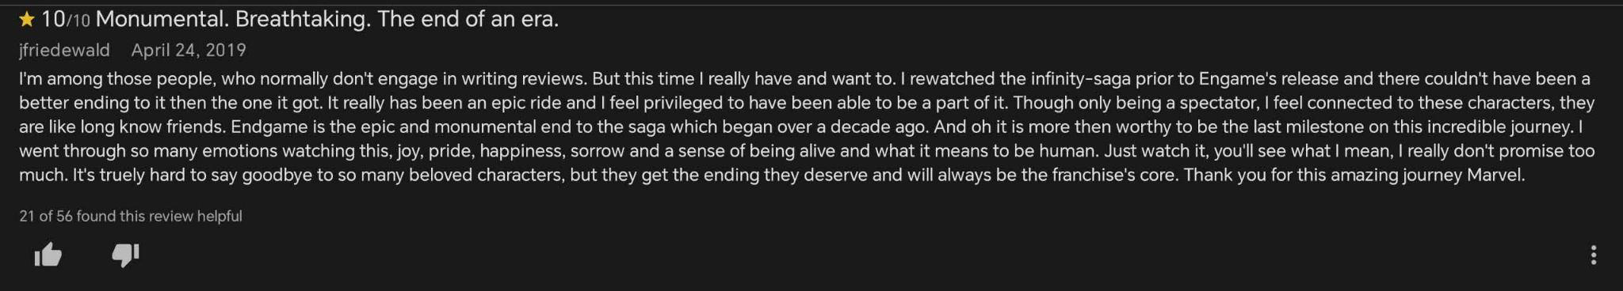
Review 2
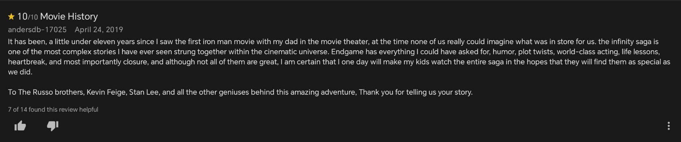
Review 3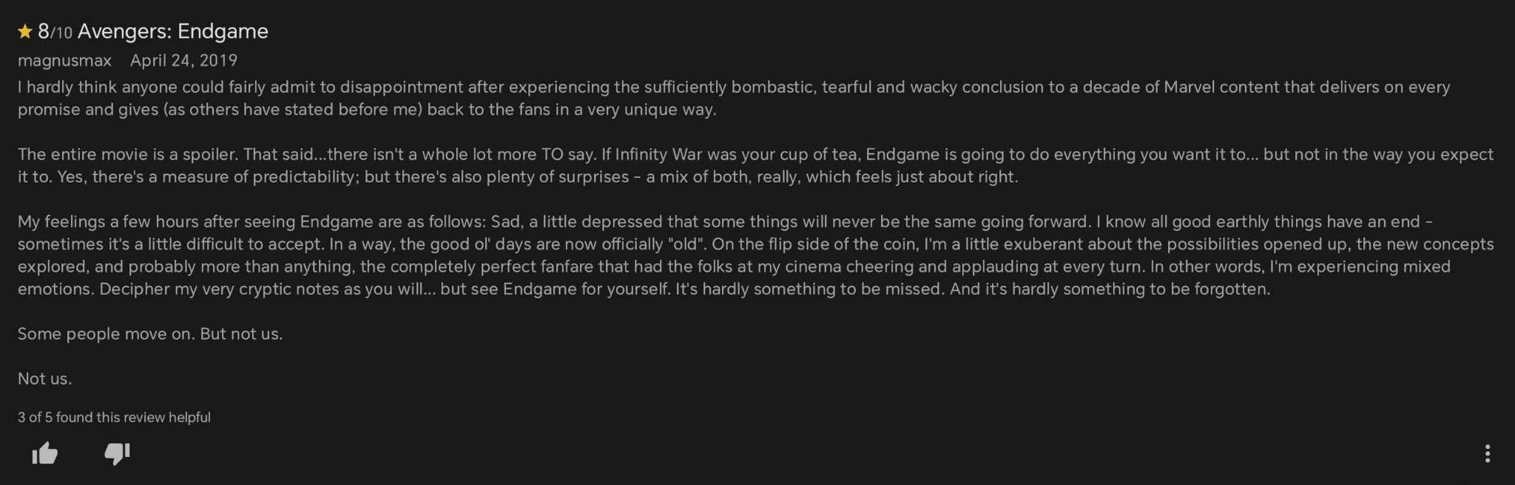
Review 4
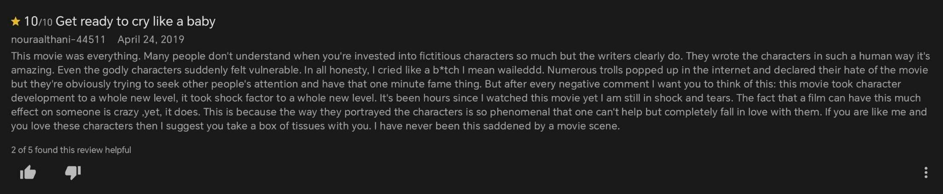

Review 5

Review 6
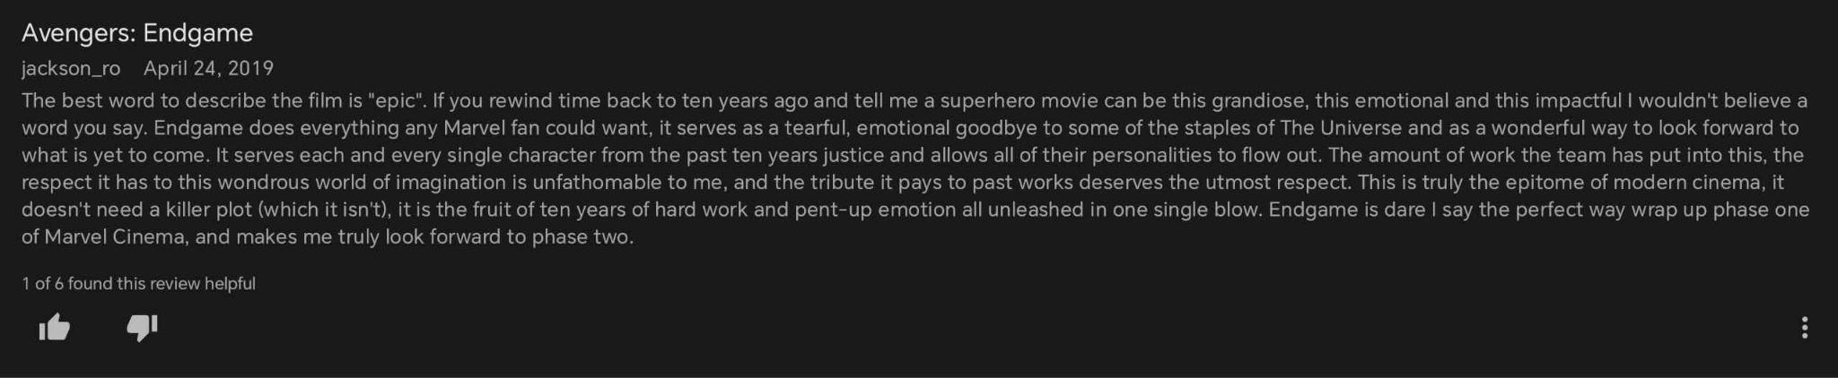
Review 7
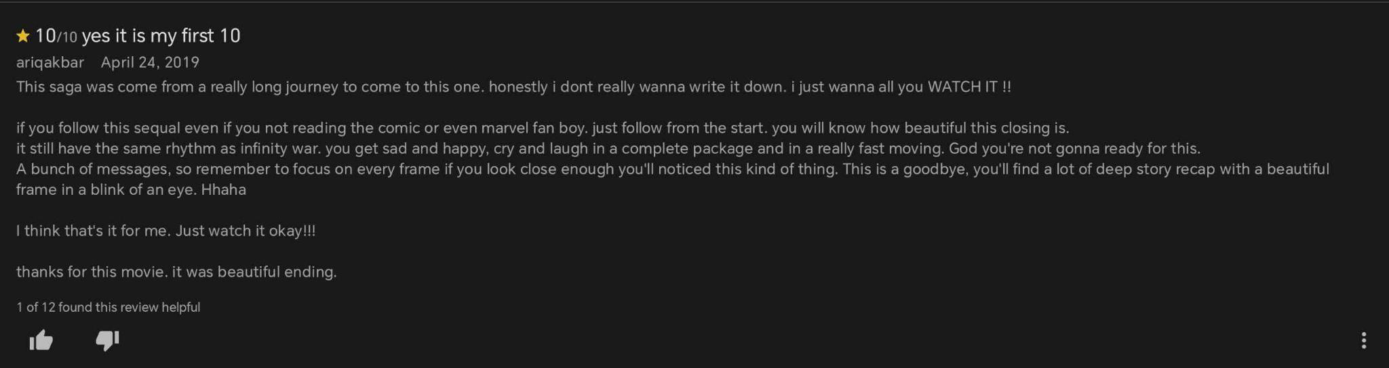
Review 8
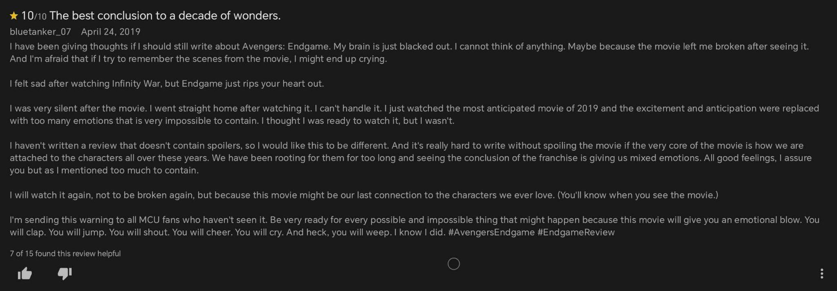
Review 9
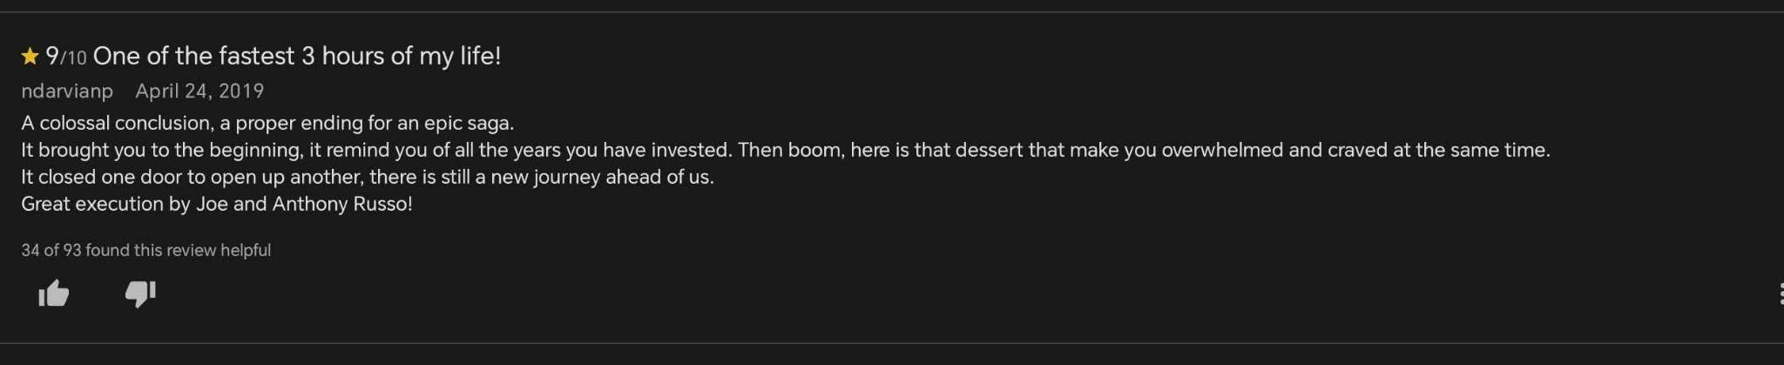
Review 10
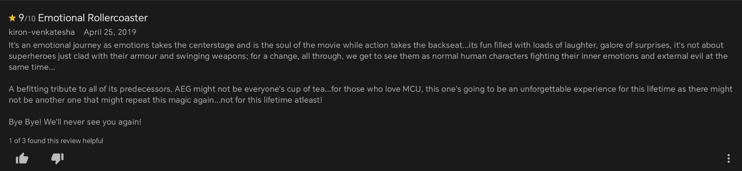
Review 11
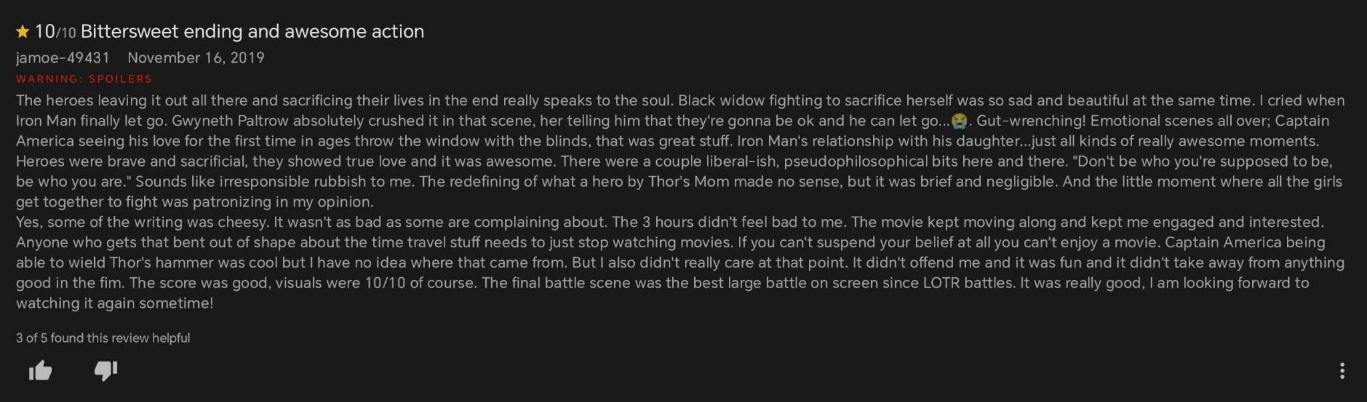
Review 12
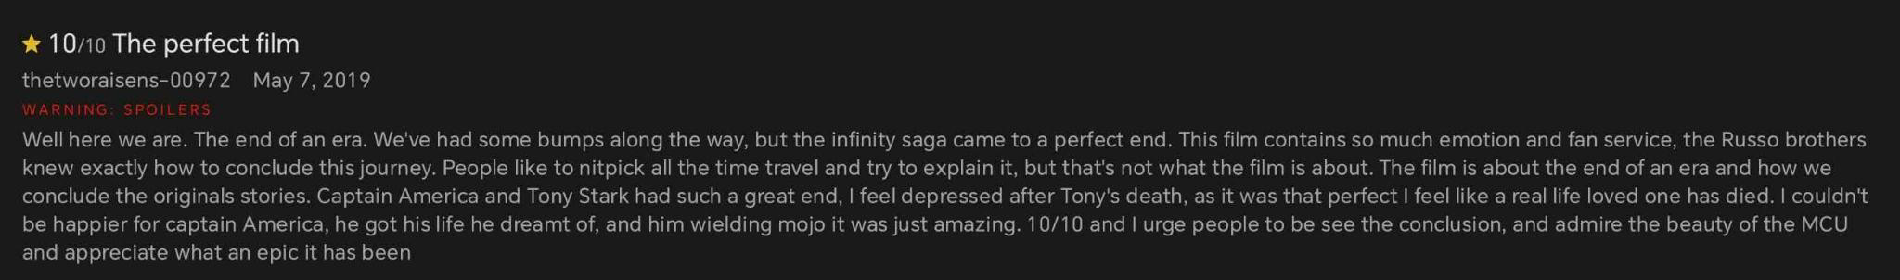
Review 13
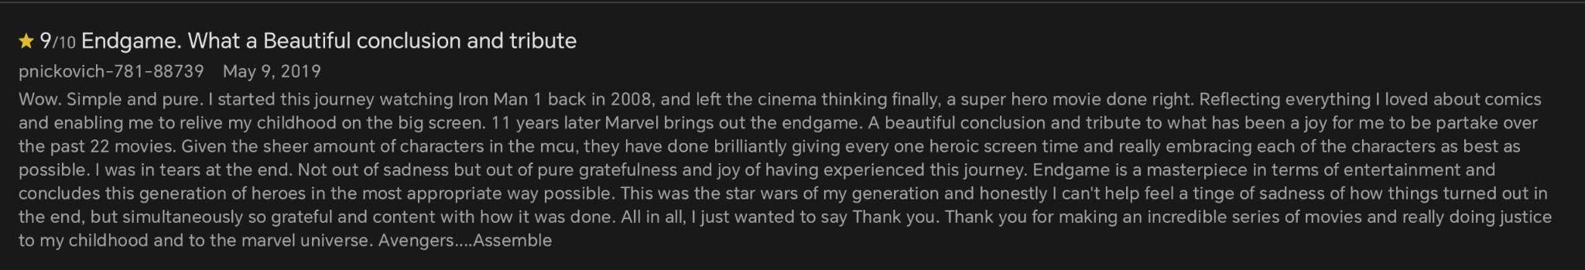
Review 14
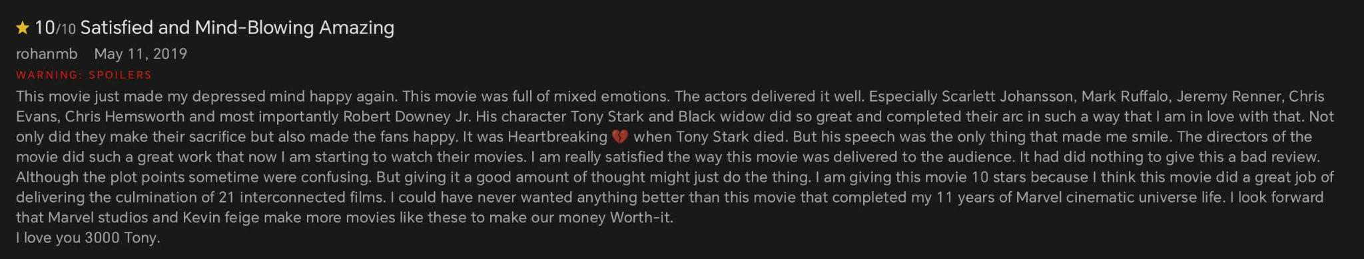

Review 15
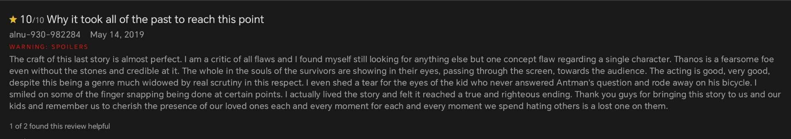
Review 16
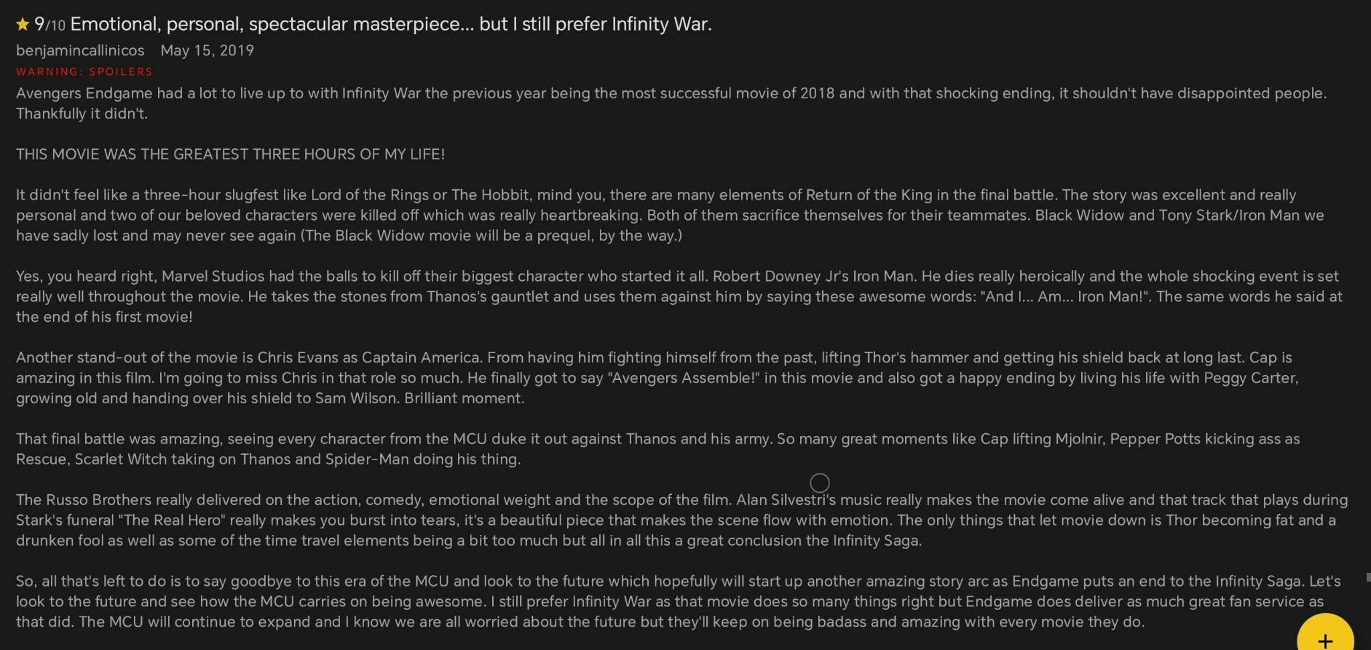
Review 17
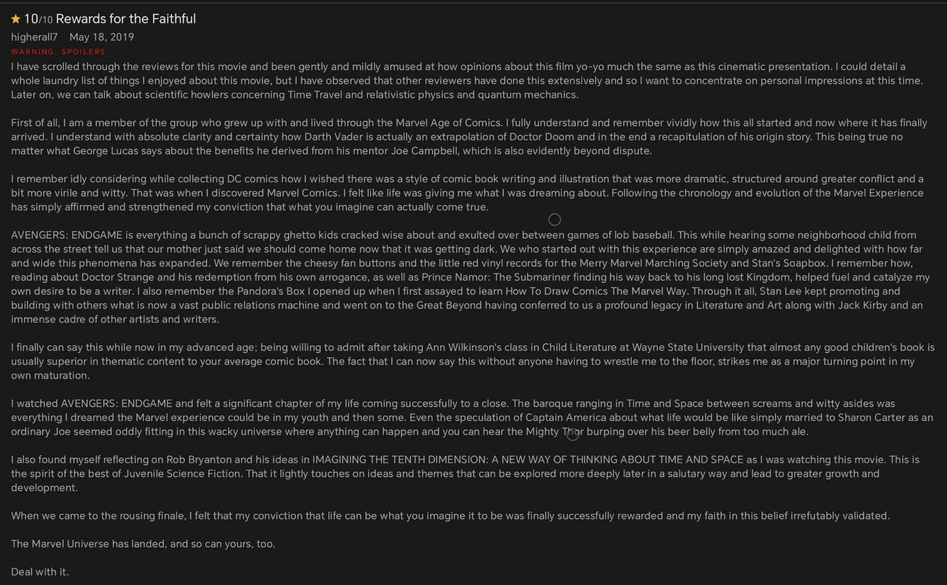
Review 18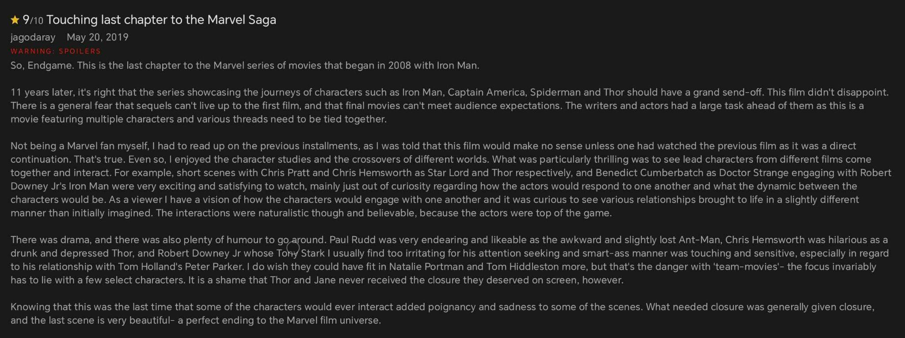
Review 19
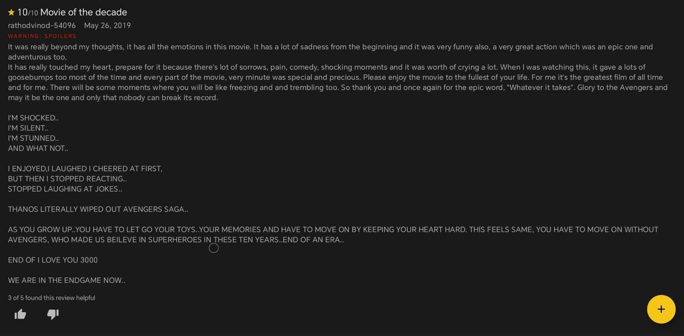

Review 20
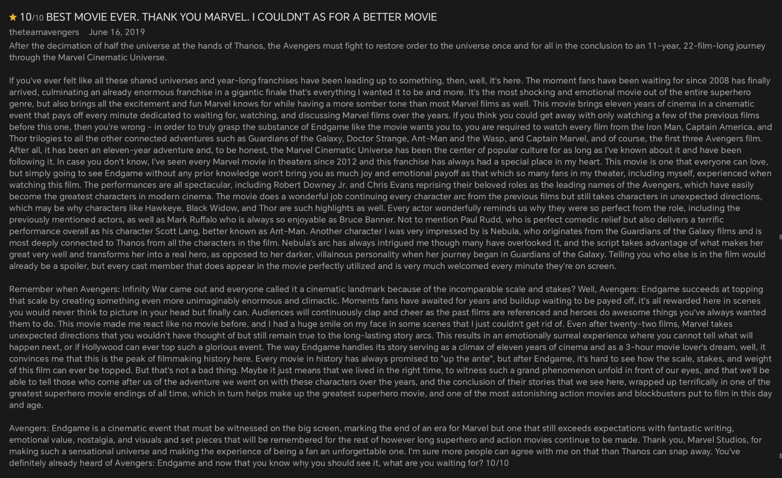
Review 21
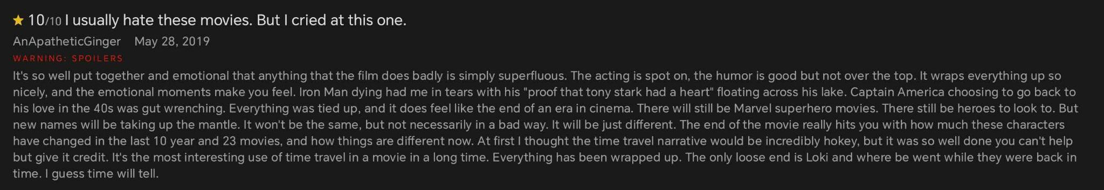
Review 22
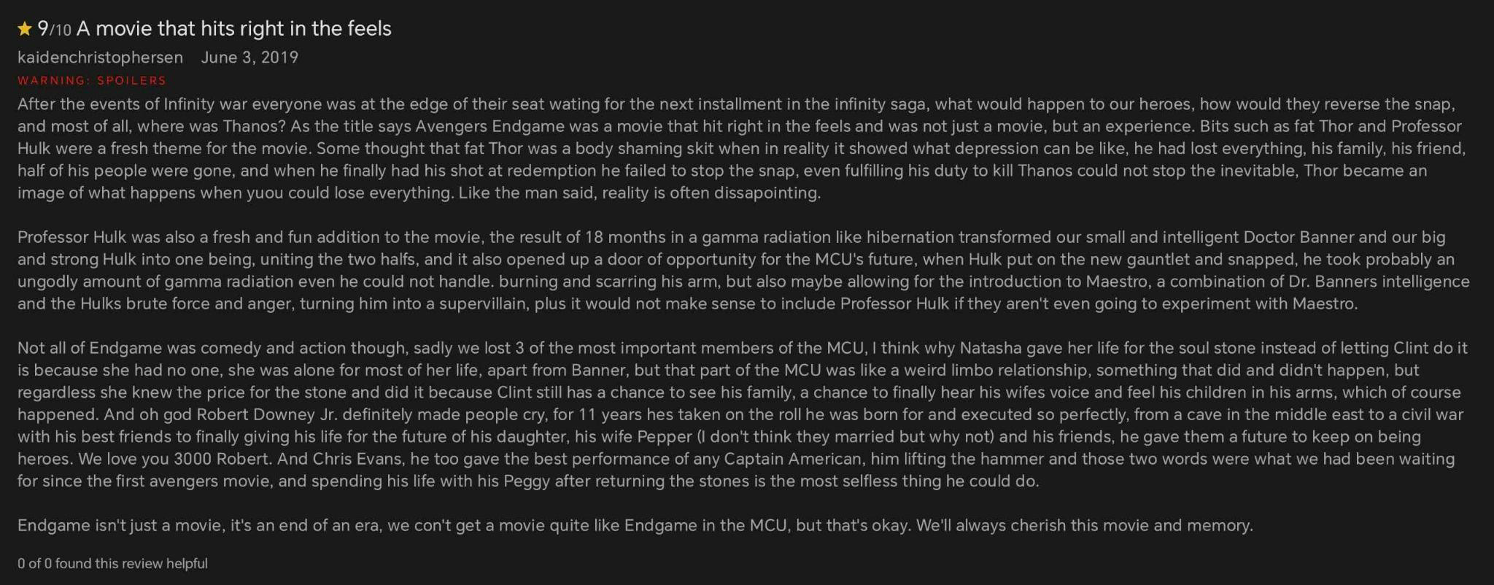

Review 23
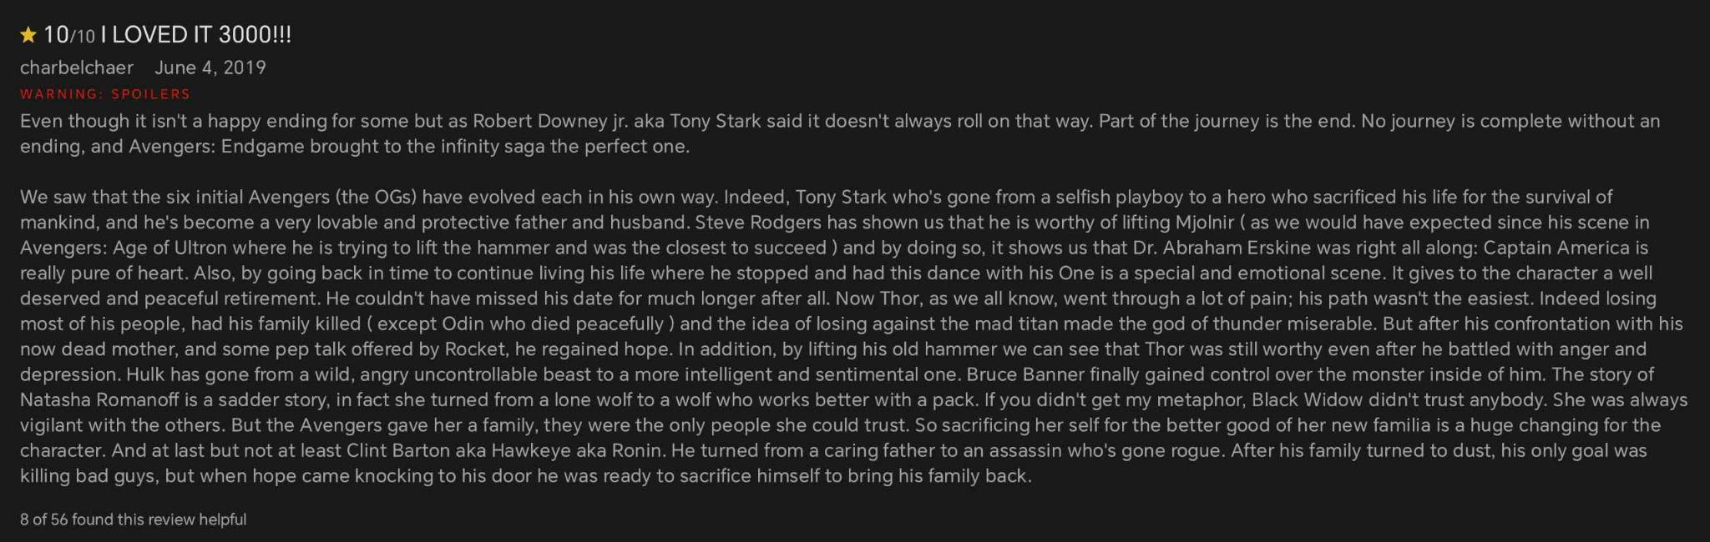
Review 24
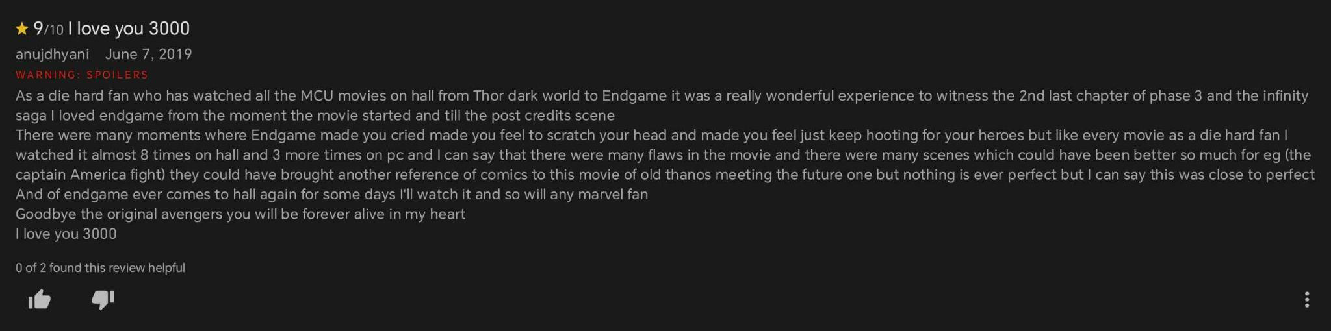
Review 25
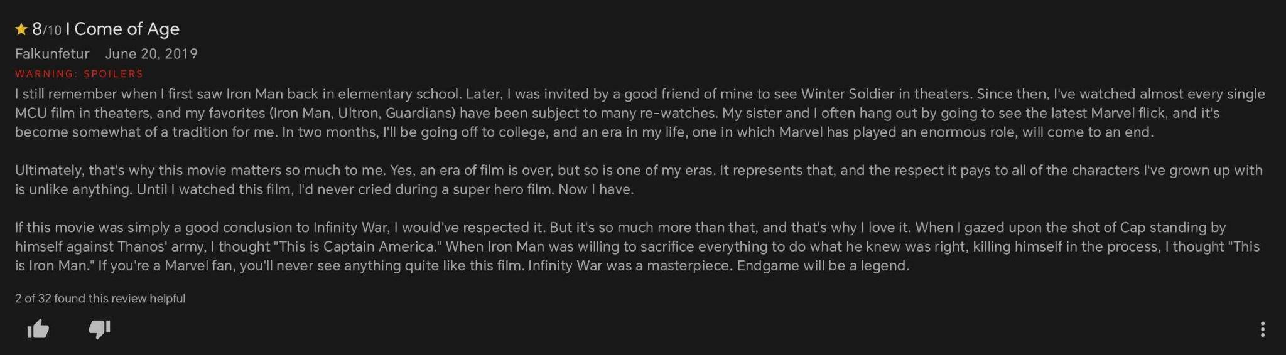

Review 26

Review 27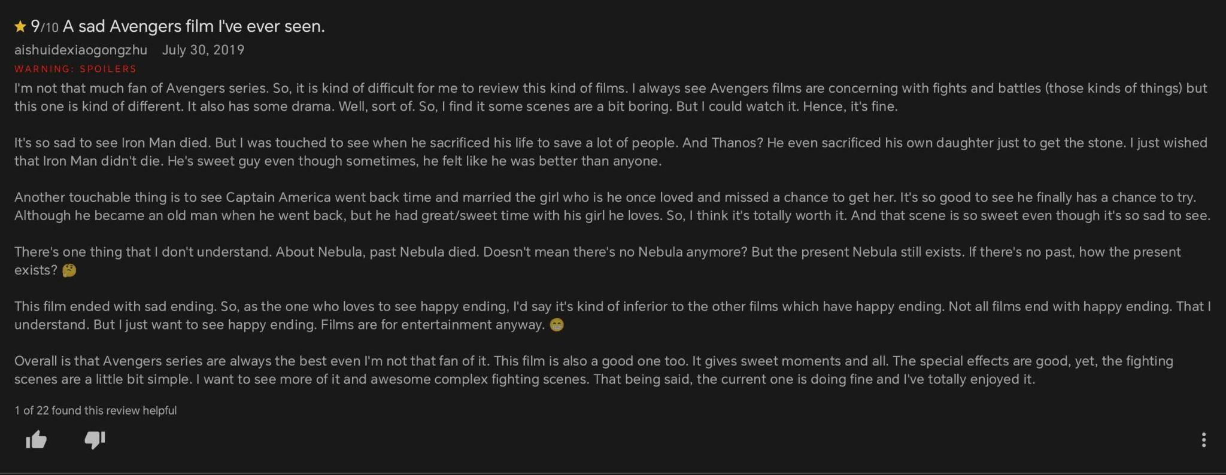
Review 28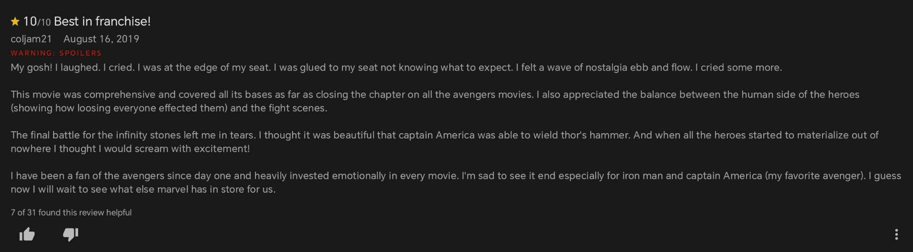
Review 29


Review 30

APPENDIX B
Individual Analysis of Reviews from IMDb

Review Extract 1
★ 10/10 Monumental. Breathtaking. The end of an era.
jfriedewald April 24, 2019

I rewatched the Infinity Saga prior to Endgame's release and there couldn't have been a better ending to it than the one it got. It really has been an epic ride and I feel privileged to have been able to be a part of it. Though only being a spectator, I feel connected to these characters, they are like long known friends. Endgame is the epic and monumental end to the saga which began over a decade ago. And it is more than worthy to be the last milestone on this incredible journey. It's truly hard to say goodbye to so many beloved characters. Thank you for this amazing journey Marvel.

Affective Lexical and Evaluative Features
Lexical Features | Classification | Category | Discursive Function
over a decade ago | temporal marker | nostalgia marker | emphasizes the long passage of time and the reviewer's enduring engagement with the film series
feel connected | affect | emotion words | expresses emotional attachment
long-known friends | affect | emotion words | expresses personal connection
privileged | affect | emotion word | expresses positive emotional involvement
hard to say goodbye | affect | grief-related vocabulary | expresses emotional difficulty in parting with the characters
beloved characters | evaluative feature | emotion words | conveys positive emotional attachment to the characters

Metaphorical Framing of Ending
Extract | Classification | Mapping | Discursive Function
It's truly hard to say goodbye to so many beloved characters. | closure as goodbye | ending — farewell | highlights the emotional process of letting go

Review Extract 2
★ 10/10 Movie History
andersdb-17025 April 24, 2019

It has been a little under eleven years since I saw the first Iron Man movie with my dad in the movie theater, at the time none of us really could imagine what was in store for us. The Infinity Saga is one of the most complex stories I have ever seen strung together within the cinematic universe. Endgame has everything I could have asked for, humor, plot twists, world-class acting, life lessons, heartbreak, and most importantly closure, and although not all of them are great, I am certain that I one day will make my kids watch the entire saga in the hopes that they will find them as special as we did.

To the Russo brothers, Kevin Feige, Stan Lee, and all the other geniuses behind this amazing adventure, thank you for telling us your story.

Affective Lexical and Evaluative Features
Linguistic Features | Classification | Category | Discursive Function
special, heartbreak, amazing | affect | emotion words | communicate admiration, emotional attachment, and sadness associated with the conclusion of the Infinity Saga
a little under eleven years, since I saw the first Iron Man movie, with my dad | temporal marker | nostalgia marker | reconstructs a personal timeline connecting past memories
heartbreak, closure | affect | emotion words | acknowledge emotional pain while recognizing the completion of a meaningful journey

Metaphorical Framing of Ending
Extract | Classification | Mapping | Discursive Function
closure; thank you for telling us your story | closure as goodbye | ending — farewell | gestated as a farewell between filmmakers and audiences, emphasizing gratitude and emotional leave-taking

Review Extract 3
★ 8/10 Avengers: Endgame
andersdb-17025 April 24, 2019
I hardly think anyone could fairly admit to disappointment after experiencing the sufficiently bombastic, tearful and wacky conclusion to a decade of Marvel content that delivers on every promise and gives (as others have stated before me) back to the fans in a very unique way.
The entire movie is a spoiler. That said...there isn't a whole lot more TO say. If Infinity War was your cup of tea, Endgame is going to do everything you want it to... but not in the way you expect it to. Yes, there's a measure of predictability; but there's also plenty of surprises – a mix of both, really, which feels just about right.

My feelings a few hours after seeing Endgame are as follows: Sad, a little depressed that some things will never be the same going forward. I know all good earthly things have an end – sometimes it's a little difficult to accept. In a way, the good ol' days are now officially "old". On the flip side of the coin, I'm a little exuberant about the possibilities opened up, the new concepts explored, and probably more than anything, the completely perfect fanfare that had the folks at my cinema cheering and applauding at every turn. In other words, I'm experiencing mixed emotions. Decipher my very cryptic notes as you will... but see Endgame for yourself. It's hardly something to be missed. And it's hardly something to be forgotten.

Some people move on. But not us.
Not us.

Affective Lexical and Evaluative Features
Linguistic Features | Classification | Category | Discursive Function
a decade of Marvel content | temporal marker | nostalgia marker | establishes the long-term duration of the reviewer’s attachment to the franchise
tearful, sad, a little depressed | affect | emotion words | expresses sadness associated with the film's conclusion
the good ol' days | temporal marker | nostalgia marker | recalls an idealized past, constructing nostalgic remembrance
mixed emotions | affect | emotion words | reflects the coexistence of grief and appreciation following the conclusion

Metaphorical Framing of Ending
Extract | Classification | Mapping | Discursive Function
some things will never be the same | ending as death | ending — irreversible loss | presents the conclusion as a changefrom which there is no return
all good earthly things have an end | ending as death | ending — termination | conceptualizes the conclusion as the inevitable termination of something valued
the good ol' days are now officially "old" | ending as death | ending — termination | frames the past as something that has permanently passed
Some people move on. But not us. | closure as goodbye | ending — farewell | interprets the ending as a farewell that the reviewer emotionally resists accepting

